**No. Members Names ID**

**1- Ahmed Riad Sayed 43243007**

**2- Gamal Ahmed Saeed 43243026**

**3- Hanaa Awad-Allah Gaber 43243103**

**4- Mohamed Essam Sayed 43243078**

**5- Mohamed Yossri Ibrahim 43243086**

**No. Members Names ID**

**1- Ahmed Riad Sayed 43243007**

**2- Gamal Ahmed Saeed 43243026**

**3- Hanaa Awad-Allah Gaber 43243103**

**4- Mohamed Essam Sayed 43243078**

**5- Mohamed Yossri Ibrahim 43243086**

**No. Members Names ID**

**1- Ahmed Riad Sayed 43243007**

**2- Gamal Ahmed Saeed 43243026**

**3- Hanaa Awad-Allah Gaber 43243103**

**4- Mohamed Essam Sayed 43243078**

**5- Mohamed Yossri Ibrahim 43243086**

**No. Members Names ID**

**1- Ahmed Riad Sayed 43243007**

**2- Gamal Ahmed Saeed 43243026**

**3- Hanaa Awad-Allah Gaber 43243103**

**4- Mohamed Essam Sayed 43243078**

**5- Mohamed Yossri Ibrahim 43243086**

**No. Members Names ID**

**1- Ahmed Riad Sayed 43243007**

**2- Gamal Ahmed Saeed 43243026**

**3- Hanaa Awad-Allah Gaber 43243103**

**4- Mohamed Essam Sayed 43243078**

**5- Mohamed Yossri Ibrahim 43243086**

**No. Members Names ID**

**1- Ahmed Riad Sayed 43243007**

**2- Gamal Ahmed Saeed 43243026**

**3- Hanaa Awad-Allah Gaber 43243103**

**4- Mohamed Essam Sayed 43243078**

**5- Mohamed Yossri Ibrahim 43243086**

**No. Members Names ID**

**1- Ahmed Riad Sayed 43243007**

**2- Gamal Ahmed Saeed 43243026**

**3- Hanaa Awad-Allah Gaber 43243103**

**4- Mohamed Essam Sayed 43243078**

**5- Mohamed Yossri Ibrahim 43243086**

**No. Members Names ID**

**1- Ahmed Riad Sayed 43243007**

**2- Gamal Ahmed Saeed 43243026**

**3- Hanaa Awad-Allah Gaber 43243103**

**4- Mohamed Essam Sayed 43243078**

**5- Mohamed Yossri Ibrahim 43243086**

**No. Members Names ID**

**1- Ahmed Riad Sayed 43243007**

**2- Gamal Ahmed Saeed 43243026**

**3- Hanaa Awad-Allah Gaber 43243103**

**4- Mohamed Essam Sayed 43243078**

**5- Mohamed Yossri Ibrahim 43243086**

**No. Members Names ID**

**1- Ahmed Riad Sayed 43243007**

**2- Gamal Ahmed Saeed 43243026**

**3- Hanaa Awad-Allah Gaber 43243103**

**4- Mohamed Essam Sayed 43243078**

**5- Mohamed Yossri Ibrahim 43243086**

**No. Members Names ID**

**1- Ahmed Riad Sayed 43243007**

**2- Gamal Ahmed Saeed 43243026**

**3- Hanaa Awad-Allah Gaber 43243103**

**4- Mohamed Essam Sayed 43243078**

**5- Mohamed Yossri Ibrahim 43243086**

**No. Members Names ID**

**1- Ahmed Riad Sayed 43243007**

**2- Gamal Ahmed Saeed 43243026**

**3- Hanaa Awad-Allah Gaber 43243103**

**4- Mohamed Essam Sayed 43243078**

**5- Mohamed Yossri Ibrahim 43243086**

**No. Members Names ID**

**1- Ahmed Riad Sayed 43243007**

**2- Gamal Ahmed Saeed 43243026**

**3- Hanaa Awad-Allah Gaber 43243103**

**4- Mohamed Essam Sayed 43243078**

**5- Mohamed Yossri Ibrahim 43243086**

**No. Members Names ID**

**1- Ahmed Riad Sayed 43243007**

**2- Gamal Ahmed Saeed 43243026**

**3- Hanaa Awad-Allah Gaber 43243103**

**4- Mohamed Essam Sayed 43243078**

**5- Mohamed Yossri Ibrahim 43243086**

**No. Members Names ID**

**1- Ahmed Riad Sayed 43243007**

**2- Gamal Ahmed Saeed 43243026**

**3- Hanaa Awad-Allah Gaber 43243103**

**4- Mohamed Essam Sayed 43243078**

**5- Mohamed Yossri Ibrahim 43243086**

**No. Members Names ID**

**1- Ahmed Riad Sayed 43243007**

**2- Gamal Ahmed Saeed 43243026**

**3- Hanaa Awad-Allah Gaber 43243103**

**4- Mohamed Essam Sayed 43243078**

**5- Mohamed Yossri Ibrahim 43243086**

**No. Members Names ID**

**1- Ahmed Riad Sayed 43243007**

**2- Gamal Ahmed Saeed 43243026**

**3- Hanaa Awad-Allah Gaber 43243103**

**4- Mohamed Essam Sayed 43243078**

**5- Mohamed Yossri Ibrahim 43243086**

**No. Members Names ID**

**1- Ahmed Riad Sayed 43243007**

**2- Gamal Ahmed Saeed 43243026**

**3- Hanaa Awad-Allah Gaber 43243103**

**4- Mohamed Essam Sayed 43243078**

**5- Mohamed Yossri Ibrahim 43243086**

**No. Members Names ID**

**1- Ahmed Riad Sayed 43243007**

**2- Gamal Ahmed Saeed 43243026**

**3- Hanaa Awad-Allah Gaber 43243103**

**4- Mohamed Essam Sayed 43243078**

**5- Mohamed Yossri Ibrahim 43243086**

**No. Members Names ID**

**1- Ahmed Riad Sayed 43243007**

**2- Gamal Ahmed Saeed 43243026**

**3- Hanaa Awad-Allah Gaber 43243103**

**4- Mohamed Essam Sayed 43243078**

**5- Mohamed Yossri Ibrahim 43243086**

**No. Members Names ID**

**1- Ahmed Riad Sayed 43243007**

**2- Gamal Ahmed Saeed 43243026**

**3- Hanaa Awad-Allah Gaber 43243103**

**4- Mohamed Essam Sayed 43243078**

**5- Mohamed Yossri Ibrahim 43243086**

**No. Members Names ID**

**1- Ahmed Riad Sayed 43243007**

**2- Gamal Ahmed Saeed 43243026**

**3- Hanaa Awad-Allah Gaber 43243103**

**4- Mohamed Essam Sayed 43243078**

**5- Mohamed Yossri Ibrahim 43243086**

**No. Members Names ID**

**1- Ahmed Riad Sayed 43243007**

**2- Gamal Ahmed Saeed 43243026**

**3- Hanaa Awad-Allah Gaber 43243103**

**4- Mohamed Essam Sayed 43243078**

**5- Mohamed Yossri Ibrahim 43243086**

**No. Members Names ID**

**1- Ahmed Riad Sayed 43243007**

**2- Gamal Ahmed Saeed 43243026**

**3- Hanaa Awad-Allah Gaber 43243103**

**4- Mohamed Essam Sayed 43243078**

**5- Mohamed Yossri Ibrahim 43243086**

**No. Members Names ID**

**1- Ahmed Riad Sayed 43243007**

**2- Gamal Ahmed Saeed 43243026**

**3- Hanaa Awad-Allah Gaber 43243103**

**4- Mohamed Essam Sayed 43243078**

**5- Mohamed Yossri Ibrahim 43243086**

**No. Members Names ID**

**1- Ahmed Riad Sayed 43243007**

**2- Gamal Ahmed Saeed 43243026**

**3- Hanaa Awad-Allah Gaber 43243103**

**4- Mohamed Essam Sayed 43243078**

**5- Mohamed Yossri Ibrahim 43243086**

**No. Members Names ID**

**1- Ahmed Riad Sayed 43243007**

**2- Gamal Ahmed Saeed 43243026**

**3- Hanaa Awad-Allah Gaber 43243103**

**4- Mohamed Essam Sayed 43243078**

**5- Mohamed Yossri Ibrahim 43243086**

**No. Members Names ID**

**1- Ahmed Riad Sayed 43243007**

**2- Gamal Ahmed Saeed 43243026**

**3- Hanaa Awad-Allah Gaber 43243103**

**4- Mohamed Essam Sayed 43243078**

**5- Mohamed Yossri Ibrahim 43243086**

**No. Members Names ID**

**1- Ahmed Riad Sayed 43243007**

**2- Gamal Ahmed Saeed 43243026**

**3- Hanaa Awad-Allah Gaber 43243103**

**4- Mohamed Essam Sayed 43243078**

**5- Mohamed Yossri Ibrahim 43243086**

**No. Members Names ID**

**1- Ahmed Riad Sayed 43243007**

**2- Gamal Ahmed Saeed 43243026**

**3- Hanaa Awad-Allah Gaber 43243103**

**4- Mohamed Essam Sayed 43243078**

**5- Mohamed Yossri Ibrahim 43243086**

**No. Members Names ID**

**1- Ahmed Riad Sayed 43243007**

**2- Gamal Ahmed Saeed 43243026**

**3- Hanaa Awad-Allah Gaber 43243103**

**4- Mohamed Essam Sayed 43243078**

**5- Mohamed Yossri Ibrahim 43243086**

**No. Members Names ID**

**1- Ahmed Riad Sayed 43243007**

**2- Gamal Ahmed Saeed 43243026**

**3- Hanaa Awad-Allah Gaber 43243103**

**4- Mohamed Essam Sayed 43243078**

**5- Mohamed Yossri Ibrahim 43243086**

**No. Members Names ID**

**1- Ahmed Riad Sayed 43243007**

**2- Gamal Ahmed Saeed 43243026**

**3- Hanaa Awad-Allah Gaber 43243103**

**4- Mohamed Essam Sayed 43243078**

**5- Mohamed Yossri Ibrahim 43243086**

**No. Members Names ID**

**1- Ahmed Riad Sayed 43243007**

**2- Gamal Ahmed Saeed 43243026**

**3- Hanaa Awad-Allah Gaber 43243103**

**4- Mohamed Essam Sayed 43243078**

**5- Mohamed Yossri Ibrahim 43243086**

**No. Members Names ID**

**1- Ahmed Riad Sayed 43243007**

**2- Gamal Ahmed Saeed 43243026**

**3- Hanaa Awad-Allah Gaber 43243103**

**4- Mohamed Essam Sayed 43243078**

**5- Mohamed Yossri Ibrahim 43243086**

**No. Members Names ID**

**1- Ahmed Riad Sayed 43243007**

**2- Gamal Ahmed Saeed 43243026**

**3- Hanaa Awad-Allah Gaber 43243103**

**4- Mohamed Essam Sayed 43243078**

**5- Mohamed Yossri Ibrahim 43243086**

**No. Members Names ID**

**1- Ahmed Riad Sayed 43243007**

**2- Gamal Ahmed Saeed 43243026**

**3- Hanaa Awad-Allah Gaber 43243103**

**4- Mohamed Essam Sayed 43243078**

**5- Mohamed Yossri Ibrahim 43243086**

**No. Members Names ID**

**1- Ahmed Riad Sayed 43243007**

**2- Gamal Ahmed Saeed 43243026**

**3- Hanaa Awad-Allah Gaber 43243103**

**4- Mohamed Essam Sayed 43243078**

**5- Mohamed Yossri Ibrahim 43243086**

**No. Members Names ID**

**1- Ahmed Riad Sayed 43243007**

**2- Gamal Ahmed Saeed 43243026**

**3- Hanaa Awad-Allah Gaber 43243103**

**4- Mohamed Essam Sayed 43243078**

**5- Mohamed Yossri Ibrahim 43243086**

**No. Members Names ID**

**1- Ahmed Riad Sayed 43243007**

**2- Gamal Ahmed Saeed 43243026**

**3- Hanaa Awad-Allah Gaber 43243103**

**4- Mohamed Essam Sayed 43243078**

**5- Mohamed Yossri Ibrahim 43243086**

**No. Members Names ID**

**1- Ahmed Riad Sayed 43243007**

**2- Gamal Ahmed Saeed 43243026**

**3- Hanaa Awad-Allah Gaber 43243103**

**4- Mohamed Essam Sayed 43243078**

**5- Mohamed Yossri Ibrahim 43243086**

**No. Members Names ID**

**1- Ahmed Riad Sayed 43243007**

**2- Gamal Ahmed Saeed 43243026**

**3- Hanaa Awad-Allah Gaber 43243103**

**4- Mohamed Essam Sayed 43243078**

**5- Mohamed Yossri Ibrahim 43243086**

**No. Members Names ID**

**1- Ahmed Riad Sayed 43243007**

**2- Gamal Ahmed Saeed 43243026**

**3- Hanaa Awad-Allah Gaber 43243103**

**4- Mohamed Essam Sayed 43243078**

**5- Mohamed Yossri Ibrahim 43243086**

**No. Members Names ID**

**1- Ahmed Riad Sayed 43243007**

**2- Gamal Ahmed Saeed 43243026**

**3- Hanaa Awad-Allah Gaber 43243103**

**4- Mohamed Essam Sayed 43243078**

**5- Mohamed Yossri Ibrahim 43243086**

**No. Members Names ID**

**1- Ahmed Riad Sayed 43243007**

**2- Gamal Ahmed Saeed 43243026**

**3- Hanaa Awad-Allah Gaber 43243103**

**4- Mohamed Essam Sayed 43243078**

**5- Mohamed Yossri Ibrahim 43243086**

**No. Members Names ID**

**1- Ahmed Riad Sayed 43243007**

**2- Gamal Ahmed Saeed 43243026**

**3- Hanaa Awad-Allah Gaber 43243103**

**4- Mohamed Essam Sayed 43243078**

**5- Mohamed Yossri Ibrahim 43243086**

**No. Members Names ID**

**1- Ahmed Riad Sayed 43243007**

**2- Gamal Ahmed Saeed 43243026**

**3- Hanaa Awad-Allah Gaber 43243103**

**4- Mohamed Essam Sayed 43243078**

**5- Mohamed Yossri Ibrahim 43243086**

**No. Members Names ID**

**1- Ahmed Riad Sayed 43243007**

**2- Gamal Ahmed Saeed 43243026**

**3- Hanaa Awad-Allah Gaber 43243103**

**4- Mohamed Essam Sayed 43243078**

**5- Mohamed Yossri Ibrahim 43243086**

**No. Members Names ID**

**1- Ahmed Riad Sayed 43243007**

**2- Gamal Ahmed Saeed 43243026**

**3- Hanaa Awad-Allah Gaber 43243103**

**4- Mohamed Essam Sayed 43243078**

**5- Mohamed Yossri Ibrahim 43243086**

**No. Members Names ID**

**1- Ahmed Riad Sayed 43243007**

**2- Gamal Ahmed Saeed 43243026**

**3- Hanaa Awad-Allah Gaber 43243103**

**4- Mohamed Essam Sayed 43243078**

**5- Mohamed Yossri Ibrahim 43243086**

**No. Members Names ID**

**1- Ahmed Riad Sayed 43243007**

**2- Gamal Ahmed Saeed 43243026**

**3- Hanaa Awad-Allah Gaber 43243103**

**4- Mohamed Essam Sayed 43243078**

**5- Mohamed Yossri Ibrahim 43243086**

**No. Members Names ID**

**1- Ahmed Riad Sayed 43243007**

**2- Gamal Ahmed Saeed 43243026**

**3- Hanaa Awad-Allah Gaber 43243103**

**4- Mohamed Essam Sayed 43243078**

**5- Mohamed Yossri Ibrahim 43243086**

**No. Members Names ID**

**1- Ahmed Riad Sayed 43243007**

**2- Gamal Ahmed Saeed 43243026**

**3- Hanaa Awad-Allah Gaber 43243103**

**4- Mohamed Essam Sayed 43243078**

**5- Mohamed Yossri Ibrahim 43243086**

**No. Members Names ID**

**1- Ahmed Riad Sayed 43243007**

**2- Gamal Ahmed Saeed 43243026**

**3- Hanaa Awad-Allah Gaber 43243103**

**4- Mohamed Essam Sayed 43243078**

**5- Mohamed Yossri Ibrahim 43243086**

**No. Members Names ID**

**1- Ahmed Riad Sayed 43243007**

**2- Gamal Ahmed Saeed 43243026**

**3- Hanaa Awad-Allah Gaber 43243103**

**4- Mohamed Essam Sayed 43243078**

**5- Mohamed Yossri Ibrahim 43243086**

**No. Members Names ID**

**1- Ahmed Riad Sayed 43243007**

**2- Gamal Ahmed Saeed 43243026**

**3- Hanaa Awad-Allah Gaber 43243103**

**4- Mohamed Essam Sayed 43243078**

**5- Mohamed Yossri Ibrahim 43243086**

**No. Members Names ID**

**1- Ahmed Riad Sayed 43243007**

**2- Gamal Ahmed Saeed 43243026**

**3- Hanaa Awad-Allah Gaber 43243103**

**4- Mohamed Essam Sayed 43243078**

**5- Mohamed Yossri Ibrahim 43243086**

**No. Members Names ID**

**1- Ahmed Riad Sayed 43243007**

**2- Gamal Ahmed Saeed 43243026**

**3- Hanaa Awad-Allah Gaber 43243103**

**4- Mohamed Essam Sayed 43243078**

**5- Mohamed Yossri Ibrahim 43243086**

**No. Members Names ID**

**1- Ahmed Riad Sayed 43243007**

**2- Gamal Ahmed Saeed 43243026**

**3- Hanaa Awad-Allah Gaber 43243103**

**4- Mohamed Essam Sayed 43243078**

**5- Mohamed Yossri Ibrahim 43243086**

**No. Members Names ID**

**1- Ahmed Riad Sayed 43243007**

**2- Gamal Ahmed Saeed 43243026**

**3- Hanaa Awad-Allah Gaber 43243103**

**4- Mohamed Essam Sayed 43243078**

**5- Mohamed Yossri Ibrahim 43243086**

**No. Members Names ID**

**1- Ahmed Riad Sayed 43243007**

**2- Gamal Ahmed Saeed 43243026**

**3- Hanaa Awad-Allah Gaber 43243103**

**4- Mohamed Essam Sayed 43243078**

**5- Mohamed Yossri Ibrahim 43243086**

**No. Members Names ID**

**1- Ahmed Riad Sayed 43243007**

**2- Gamal Ahmed Saeed 43243026**

**3- Hanaa Awad-Allah Gaber 43243103**

**4- Mohamed Essam Sayed 43243078**

**5- Mohamed Yossri Ibrahim 43243086**

**No. Members Names ID**

**1- Ahmed Riad Sayed 43243007**

**2- Gamal Ahmed Saeed 43243026**

**3- Hanaa Awad-Allah Gaber 43243103**

**4- Mohamed Essam Sayed 43243078**

**5- Mohamed Yossri Ibrahim 43243086**

**No. Members Names ID**

**1- Ahmed Riad Sayed 43243007**

**2- Gamal Ahmed Saeed 43243026**

**3- Hanaa Awad-Allah Gaber 43243103**

**4- Mohamed Essam Sayed 43243078**

**5- Mohamed Yossri Ibrahim 43243086**

Supervised by: Dr Hossam El-Din Ebrahim

Supervised by: Dr Hossam El-Din Ebrahim

Supervised by: Dr Hossam El-Din Ebrahim

Supervised by: Dr Hossam El-Din Ebrahim

Supervised by: Dr Hossam El-Din Ebrahim

Supervised by: Dr Hossam El-Din Ebrahim

Supervised by: Dr Hossam El-Din Ebrahim

Supervised by: Dr Hossam El-Din Ebrahim

Supervised by: Dr Hossam El-Din Ebrahim

Supervised by: Dr Hossam El-Din Ebrahim

Supervised by: Dr Hossam El-Din Ebrahim

Supervised by: Dr Hossam El-Din Ebrahim

Supervised by: Dr Hossam El-Din Ebrahim

Supervised by: Dr Hossam El-Din Ebrahim

Supervised by: Dr Hossam El-Din Ebrahim

Supervised by: Dr Hossam El-Din Ebrahim

Supervised by: Dr Hossam El-Din Ebrahim

Supervised by: Dr Hossam El-Din Ebrahim

Supervised by: Dr Hossam El-Din Ebrahim

Supervised by: Dr Hossam El-Din Ebrahim

Supervised by: Dr Hossam El-Din Ebrahim

Supervised by: Dr Hossam El-Din Ebrahim

Supervised by: Dr Hossam El-Din Ebrahim

Supervised by: Dr Hossam El-Din Ebrahim

Supervised by: Dr Hossam El-Din Ebrahim

Supervised by: Dr Hossam El-Din Ebrahim

Supervised by: Dr Hossam El-Din Ebrahim

Supervised by: Dr Hossam El-Din Ebrahim

Supervised by: Dr Hossam El-Din Ebrahim

Supervised by: Dr Hossam El-Din Ebrahim

Supervised by: Dr Hossam El-Din Ebrahim

Supervised by: Dr Hossam El-Din Ebrahim

Supervised by: Dr Hossam El-Din Ebrahim

Supervised by: Dr Hossam El-Din Ebrahim

Supervised by: Dr Hossam El-Din Ebrahim

Supervised by: Dr Hossam El-Din Ebrahim

Supervised by: Dr Hossam El-Din Ebrahim

Supervised by: Dr Hossam El-Din Ebrahim

Supervised by: Dr Hossam El-Din Ebrahim

Supervised by: Dr Hossam El-Din Ebrahim

Supervised by: Dr Hossam El-Din Ebrahim

Supervised by: Dr Hossam El-Din Ebrahim

Supervised by: Dr Hossam El-Din Ebrahim

Supervised by: Dr Hossam El-Din Ebrahim

Supervised by: Dr Hossam El-Din Ebrahim

Supervised by: Dr Hossam El-Din Ebrahim

Supervised by: Dr Hossam El-Din Ebrahim

Supervised by: Dr Hossam El-Din Ebrahim

Supervised by: Dr Hossam El-Din Ebrahim

Supervised by: Dr Hossam El-Din Ebrahim

Supervised by: Dr Hossam El-Din Ebrahim

Supervised by: Dr Hossam El-Din Ebrahim

Supervised by: Dr Hossam El-Din Ebrahim

Supervised by: Dr Hossam El-Din Ebrahim

Supervised by: Dr Hossam El-Din Ebrahim

Supervised by: Dr Hossam El-Din Ebrahim

Supervised by: Dr Hossam El-Din Ebrahim

Supervised by: Dr Hossam El-Din Ebrahim

Supervised by: Dr Hossam El-Din Ebrahim

Supervised by: Dr Hossam El-Din Ebrahim

Supervised by: Dr Hossam El-Din Ebrahim

Supervised by: Dr Hossam El-Din Ebrahim

Supervised by: Dr Hossam El-Din Ebrahim

Supervised by: Dr Hossam El-Din Ebrahim

**Helwan University**

**Faculty of Engineering**

**Computer Engineering Department**

**Academic Year 2023-2024**

**Helwan University**

**Faculty of Engineering**

**Computer Engineering Department**

**Academic Year 2023-2024**

**Helwan University**

**Faculty of Engineering**

**Computer Engineering Department**

**Academic Year 2023-2024**

**Helwan University**

**Faculty of Engineering**

**Computer Engineering Department**

**Academic Year 2023-2024**

**Helwan University**

**Faculty of Engineering**

**Computer Engineering Department**

**Academic Year 2023-2024**

**Helwan University**

**Faculty of Engineering**

**Computer Engineering Department**

**Academic Year 2023-2024**

**Helwan University**

**Faculty of Engineering**

**Computer Engineering Department**

**Academic Year 2023-2024**

**Helwan University**

**Faculty of Engineering**

**Computer Engineering Department**

**Academic Year 2023-2024**

**Helwan University**

**Faculty of Engineering**

**Computer Engineering Department**

**Academic Year 2023-2024**

**Helwan University**

**Faculty of Engineering**

**Computer Engineering Department**

**Academic Year 2023-2024**

**Helwan University**

**Faculty of Engineering**

**Computer Engineering Department**

**Academic Year 2023-2024**

**Helwan University**

**Faculty of Engineering**

**Computer Engineering Department**

**Academic Year 2023-2024**

**Helwan University**

**Faculty of Engineering**

**Computer Engineering Department**

**Academic Year 2023-2024**

**Helwan University**

**Faculty of Engineering**

**Computer Engineering Department**

**Academic Year 2023-2024**

**Helwan University**

**Faculty of Engineering**

**Computer Engineering Department**

**Academic Year 2023-2024**

**Helwan University**

**Faculty of Engineering**

**Computer Engineering Department**

**Academic Year 2023-2024**

**Helwan University**

**Faculty of Engineering**

**Computer Engineering Department**

**Academic Year 2023-2024**

**Helwan University**

**Faculty of Engineering**

**Computer Engineering Department**

**Academic Year 2023-2024**

**Helwan University**

**Faculty of Engineering**

**Computer Engineering Department**

**Academic Year 2023-2024**

**Helwan University**

**Faculty of Engineering**

**Computer Engineering Department**

**Academic Year 2023-2024**

**Helwan University**

**Faculty of Engineering**

**Computer Engineering Department**

**Academic Year 2023-2024**

**Helwan University**

**Faculty of Engineering**

**Computer Engineering Department**

**Academic Year 2023-2024**

**Helwan University**

**Faculty of Engineering**

**Computer Engineering Department**

**Academic Year 2023-2024**

**Helwan University**

**Faculty of Engineering**

**Computer Engineering Department**

**Academic Year 2023-2024**

**Helwan University**

**Faculty of Engineering**

**Computer Engineering Department**

**Academic Year 2023-2024**

**Helwan University**

**Faculty of Engineering**

**Computer Engineering Department**

**Academic Year 2023-2024**

**Helwan University**

**Faculty of Engineering**

**Computer Engineering Department**

**Academic Year 2023-2024**

**Helwan University**

**Faculty of Engineering**

**Computer Engineering Department**

**Academic Year 2023-2024**

**Helwan University**

**Faculty of Engineering**

**Computer Engineering Department**

**Academic Year 2023-2024**

**Helwan University**

**Faculty of Engineering**

**Computer Engineering Department**

**Academic Year 2023-2024**

**Helwan University**

**Faculty of Engineering**

**Computer Engineering Department**

**Academic Year 2023-2024**

**Helwan University**

**Faculty of Engineering**

**Computer Engineering Department**

**Academic Year 2023-2024**

**Helwan University**

**Faculty of Engineering**

**Computer Engineering Department**

**Academic Year 2023-2024**

**Helwan University**

**Faculty of Engineering**

**Computer Engineering Department**

**Academic Year 2023-2024**

**Helwan University**

**Faculty of Engineering**

**Computer Engineering Department**

**Academic Year 2023-2024**

**Helwan University**

**Faculty of Engineering**

**Computer Engineering Department**

**Academic Year 2023-2024**

**Helwan University**

**Faculty of Engineering**

**Computer Engineering Department**

**Academic Year 2023-2024**

**Helwan University**

**Faculty of Engineering**

**Computer Engineering Department**

**Academic Year 2023-2024**

**Helwan University**

**Faculty of Engineering**

**Computer Engineering Department**

**Academic Year 2023-2024**

**Helwan University**

**Faculty of Engineering**

**Computer Engineering Department**

**Academic Year 2023-2024**

**Helwan University**

**Faculty of Engineering**

**Computer Engineering Department**

**Academic Year 2023-2024**

**Helwan University**

**Faculty of Engineering**

**Computer Engineering Department**

**Academic Year 2023-2024**

**Helwan University**

**Faculty of Engineering**

**Computer Engineering Department**

**Academic Year 2023-2024**

**Helwan University**

**Faculty of Engineering**

**Computer Engineering Department**

**Academic Year 2023-2024**

**Helwan University**

**Faculty of Engineering**

**Computer Engineering Department**

**Academic Year 2023-2024**

**Helwan University**

**Faculty of Engineering**

**Computer Engineering Department**

**Academic Year 2023-2024**

**Helwan University**

**Faculty of Engineering**

**Computer Engineering Department**

**Academic Year 2023-2024**

**Helwan University**

**Faculty of Engineering**

**Computer Engineering Department**

**Academic Year 2023-2024**

**Helwan University**

**Faculty of Engineering**

**Computer Engineering Department**

**Academic Year 2023-2024**

**Helwan University**

**Faculty of Engineering**

**Computer Engineering Department**

**Academic Year 2023-2024**

**Helwan University**

**Faculty of Engineering**

**Computer Engineering Department**

**Academic Year 2023-2024**

**Helwan University**

**Faculty of Engineering**

**Computer Engineering Department**

**Academic Year 2023-2024**

**Helwan University**

**Faculty of Engineering**

**Computer Engineering Department**

**Academic Year 2023-2024**

**Helwan University**

**Faculty of Engineering**

**Computer Engineering Department**

**Academic Year 2023-2024**

**Helwan University**

**Faculty of Engineering**

**Computer Engineering Department**

**Academic Year 2023-2024**

**Helwan University**

**Faculty of Engineering**

**Computer Engineering Department**

**Academic Year 2023-2024**

**Helwan University**

**Faculty of Engineering**

**Computer Engineering Department**

**Academic Year 2023-2024**

**Helwan University**

**Faculty of Engineering**

**Computer Engineering Department**

**Academic Year 2023-2024**

**Helwan University**

**Faculty of Engineering**

**Computer Engineering Department**

**Academic Year 2023-2024**

**Helwan University**

**Faculty of Engineering**

**Computer Engineering Department**

**Academic Year 2023-2024**

**Helwan University**

**Faculty of Engineering**

**Computer Engineering Department**

**Academic Year 2023-2024**

**Helwan University**

**Faculty of Engineering**

**Computer Engineering Department**

**Academic Year 2023-2024**

**Helwan University**

**Faculty of Engineering**

**Computer Engineering Department**

**Academic Year 2023-2024**

**Helwan University**

**Faculty of Engineering**

**Computer Engineering Department**

**Academic Year 2023-2024**



**“We extend all love, respect and appreciation to the distinguished doctors, who have illuminated our path with more knowledge and knowledge.”**

# Acknowledgement

Dear **Dr. Hossam El-din Ebrahim**,

We would like to express our heartfelt gratitude for your invaluable guidance and support throughout our graduation project. Your expertise, patience, and encouragement have been instrumental in helping us achieve our goals.

Thank you for always being available to provide insights and for challenging us to think critically and creatively. Your mentorship has not only enriched our academic experience but also prepared us for future endeavors.

We are deeply grateful for your dedication and for believing in our potential. It has been an honor to work under your supervision.

Sincerely,

**Team Members**

# Individual Contributions

**Table 1: Individual Contributions**

|  |  |
| --- | --- |
| **Name** | **Contribution** |
| **Ahmed Riad Sayed** | * Front End development (UI) * Back End – Database – * Software Testing * Sequence Diagram * UI / UX Design |
| **Gamal Ahmed Saeed** | * Porting FreeRTOS * MQTT –Controller Side- * HAL Drivers * ESP01 Interfacing * GPS Interfacing * Backend – Database - |
| **Hanaa Awad-Allah Gaber** | * Porting FreeRTOS * MCAL Drivers * Use Case Diagram * HAL Drivers * ADXL Interfacing |
| **Mohamad Essam Sayed** | * Back End Development * MQTT -Website Side- * ER Diagram * Relational Model * Software Testing |
| **Mohamad Yossri Ibrahim** | * MCAL Drivers * HAL Drivers * Sequence Diagram * Porting FreeRTOS * RFID Interfacing |

# Abstract

The proposed smart school bus tracking system is an easy-to-use software, including both a web-based part and an Embedded System part, that mainly gives parents and school the ability to track accurately the location of their school service vehicles. Such a smart school bus service information system is inevitable within the context of smart city features. The web-based makes it smarter for parents and school using their school services; also, parents can easily track their students' buses. In addition, Schools can easily register new students and determine the routes of the school buses dynamically. The system provides scalability, flexibility, low cost, security, and reliability. All shared location information and users' private data are stored encrypted; the parents may receive information about their related buses. The system is based on both web platform and embedded system, and it is implemented as an interactive application.

**Table of Contents**

Acknowledgement 2

Individual Contributions 3

Abstract 4

List of Figures 8

List of Tables 9

Chapter 1: Introduction

1.1 Introduction 11

1.2 Problem Statement 12

1.3 Motivation 13

1.4 Objective 14

1.5 Project Idea 15

Chapter 2: Related Work

2.1 Related Work 17

2.1.1 GPS-Based School Tracking System 18

2.1.2 Department of Computer Science the university of Lahore 19

Chapter 3: Analysis Requirements

3.1 System Requirements 21

3.1.1 Functional Requirements 21

3.1.2 Non-functional Requirements 25

3.2 Functional Requirements Specification 27

3.2.1 Stakeholders and End Users 27

3.2.2 Actors and Goals 29

Chapter 4: Design

4.1 System Architecture 31

4.1.1 Block Diagram 31

4.1.2 Communication Path 32

4.1.3 System Architecture 33

4.1.4 Deliverables 34

4.1.4.1 Hardware Package 34

4.1.4.2 Software Package 35

4.2 Entity-Relation Diagram (ERD) 35

4.3 Relational Model 37

4.4 Use-Case Diagram 39

4.5 Sequence Diagram 41

4.5.1 Sequence Diagram (IT-Manager) 42

4.5.2 Sequence Diagram (Administrator) 43

4.5.3 Sequence Diagram (Parent) 44

Chapter 5: Tools & Technologies

5.1 Embedded Systems 46

5.2 Software Tools 47

5.2.1 Website Tools 47

5.2.1.1 Hyper Text Markup Language (HTML) 47

5.2.1.2 Cascading Style Sheet (CSS) 48

5.2.1.3 JavaScript Language 49

5.2.1.4 React-JS Framework 50

5.2.1.5 Bootstrap Framework 51

5.2.1.6 Leaflet (software) 51

5.2.1.7 JSON 52

5.2.1.8 Database- MYSQL 52

5.2.1.9 PHP 53

5.2.1.10 Laravel Framework 54

5.2.1.11 XAMPP 55

5.2.1.12 Postman (software) 55

5.2.2 IOT Protocols and Techniques 56

5.2.2.1 Hyper-Text Transfer Protocol (HTTP) 56

5.2.2.2 Message Queuing Telemetry Transport protocol (MQTT) 57

5.2.2.3 PubSubClient Library 58

5.2.3 Free RTOS 59

5.2.3.1 Concurrency and Multi-tasking 59

5.2.3.2 Kernel: 60

5.2.3.3 Scheduler: 61

5.2.3.4 Task States 62

5.2.3.5 Inter-Task Communication & Synchronization 63

5.3 Hardware Tools 65

5.3.1 ATMEGA128 (MCU) 65

5.3.2 ESP-01 (WI-FI Module) 67

5.3.3 Accelerometer sensor (ADXL345) 69

5.3.4 GPS Module (NEO6) 74

5.3.5 RFID (MFRC522) 77

5.3.6 LCD (16*4) 81

Chapter 6: User Interface

6.1 Login and Sign Up 84

6.2 Admin 86

6.4 Parent 94

Chapter 7: Testing

7.1 Testing 98

7.2 Login (IT-Manager-Administrator-Parent) 100

7.3 Add Admin 101

7.4 Add Student 102

7.5 Parent Registration 104

7.6 Delete (Admin-Parent-Student) 105

7.7 Edit (Admin-Parent-Student) 105

7.8 Search Student Attendance 106

Chapter 8: Conclusion & Future Work

8.1 Conclusion 108

8.2 Future Work 109

Chapter 9: References

9.1 References 111

# List of Figures

**Figure 1: Block Diagram 31**

**Figure 2: Communication Path 32**

**Figure 3: System Architecture 33**

**Figure 4: Entity Relationship Diagram (ERD) 36**

**Figure 5: Relational Model 38**

**Figure 6: Use-Case Diagram 40**

**Figure 7: Sequence Diagram (IT-Manager) 42**

**Figure 8: Sequence Diagram (Administrator) 43**

**Figure 9: Sequence Diagram (Parent) 44**

**Figure 10: True Concurrent Execution 59**

**Figure 11: Pseudo Concurrent Execution 60**

**Figure 12: Kernel Structure 60**

**Figure 13: Preemptive Scheduler 61**

**Figure 14: Non-Preemptive Scheduler 61**

**Figure 15: Task States 62**

**Figure 16: Semaphore 63**

**Figure 17: Priority Inversion 64**

**Figure 18: Priority Inheritance 64**

**Figure 19: ATMega128 65**

**Figure 20: ESP-01 (Wi-Fi Module) 67**

**Figure 21: ESP-01 Description 68**

**Figure 22: ADXL-345 (Accelerometer) 69**

**Figure 23: ADXL-345 Hardware Component 69**

**Figure 24: GPS Neo-6M 74**

**Figure 25: GPGGA LOG 76**

**Figure 26: RFID (MFRC522) 77**

**Figure 27: RFID (MFRC522) Description 78**

**Figure 28: RFID Tag 80**

**Figure 29: LCD (Liquid Crystal Display) 81**

**Figure 30: Website Login Page 84**

**Figure 31: Website Signup Page 84**

**Figure 32: Verifying Page 85**

**Figure 33: Admin Homepage 86**

**Figure 34: Student Attendance Data 87**

**Figure 35: Student Absence Page 87**

**Figure 36: Add Tag Page 88**

**Figure 37: Update Tag Page 88**

**Figure 38: Add Student Page 89**

**Figure 39: Update Student Page 89**

**Figure 40: Student Tags Page 90**

**Figure 41: Parent Data Page 91**

**Figure 42: Add Admin Page 91**

**Figure 43: Status of Students Page 92**

**Figure 44: Bus Status Page 92**

**Figure 45: Bus Location Page 93**

**Figure 46: Admin Data Page 93**

**Figure 47: Parent Homepage 94**

**Figure 48: Sons Status Page 95**

**Figure 49: Sons Absence Page 95**

**Figure 50: Notification Panel 96**

**Figure 51: Tracking Page for Parent 96**

# List of Tables

**Table 1: Individual Contributions** 3

**Table 2: Functional Requirement Table** 21

**Table 3: Non-Functional Requirement Table** 25

**Table 4: Login (IT-Manager-Administrator-Parent) Testing** 100

**Table 5: Add Admin Testing** 101

**Table 6: Add Student Testing** 102

**Table 7: Parent Regiseration Testing** 104

**Table 8: Delete (Admin-Parnet-Student) Testing** 105

**Table 9: Edit (Admin-Parent-Student) Testing** 105

**Table 10: Search Student Attendance Testing** 106





**Chapter 1**

**Introduction**

# Introduction

On daily basis approx. 450000 school buses are used by schools to pick and drop around 20 million students from home and school in Egypt. For the parents of school going Childs, School buses are the most trusted mode of transport. School Bus Tracker is a simple System created to help parents ensure their children’s safety.

Our project idea is categorized as a tracking system that can be implemented to be used in schools especially the remote schools. In the realm of school transportation, the need for an efficient and reliable system is paramount. The challenges associated with managing school buses, ensuring student safety, and maintaining effective communication have become increasingly apparent. To overcome these obstacles, a transformative solution is required. By harnessing the power of real-time tracking. This aim can be applied by the help of the loT technology that connect between an embedded system and a website. The journey to and from school becomes not only safer and more streamlined but also an opportunity to enhance operational efficiency and foster a sense of trust and satisfaction among parents.

# Problem Statement

Inefficient School Bus Management and Lack of Student Safety Monitoring.

The current school transportation system in many areas suffers from inefficiencies and a lack of effective monitoring, leading to concerns regarding student safety and operational management. There is a need for a solution that can address these challenges and provide a reliable and efficient bus tracking system.

The problems here are:

* Inconsistent and unreliable bus timings cause confusion and delays, disrupting the daily transportation routine for students, parents, and school staff.
* The absence of a bus tracking system makes it challenging to hold bus drivers accountable for their actions, compromising student safety and lacking transparency.
* Inefficient resource allocation results from a lack of tracking and data analysis, with buses operating at low capacity or overcrowded due to inadequate understanding of transportation demand.
* Limited emergency preparedness due to the absence of a tracking system hampers quick response and assistance during breakdowns or accidents involving school buses.
* Manual record-keeping methods create challenges in tracking bus routes, student attendance, and maintenance schedules, leading to errors, delays, and difficulties in accessing critical information.
* Parental concerns and communication gaps arise without a bus tracking system, causing anxiety and uncertainty about student safety during transportation and hindering effective communication between schools and parents.

# Motivation

The motivation behind implementing a school bus tracking system stems from the pressing need to enhance student safety, improve operational efficiency, and provide peace of mind to parents and school authorities. By leveraging technology and real-time tracking, schools can address the shortcomings of the current transportation system, reducing concerns related to delays, accountability, and emergency response. The motivation is to create a secure and transparent environment that instills confidence in parents while optimizing bus routes and schedules for better resource utilization.

# Objective

The main goal of our project is to develop a school bus tracking system that uses advanced technologies to address the challenges faced by providing:

* Real Time Tracking: Develop a system capable of real-time tracking of school buses, ensuring accurate location.
* Communication Interface: Establish a reliable communication interface between the embedded system and the web interface, allowing seamless data exchange.
* Attendance Monitoring: track student attendance as they board and exit the bus, providing automated attendance records.
* Custom Alerts: Implement custom alert mechanisms to notify stakeholders in case of emergencies, delays, or deviations from predefined routes.
* User Accessibility: Design a user-friendly web interface accessible to stakeholders including school administrators, bus drivers, and parents, providing relevant and timely information.
* Safety Assurance: Utilize accelerometer data to monitor and detect sudden movements or accidents, ensuring the safety of students onboard.

# Project Idea

The aim of the Smart School Bus Management System project is to enhance the safety, efficiency, and transparency of school bus transportation. By integrating advanced technologies such as GPS tracking, student identification systems, collision detection sensors, and speed monitoring, the project seeks to provide real-time, reliable information to both parents and school administrators. The primary objective is to enable parents to track the live location of their child's school bus, ensuring peace of mind and timely awareness of arrivals and departures.

Additionally, the system aims to empower school administrators with centralized monitoring capabilities, allowing them to optimize bus routes, respond promptly to deviations, and enhance overall fleet management. With an emphasis on student safety, the project aspires to minimize risks through collision detection mechanisms and speed monitoring, contributing to a secure and efficient school transportation ecosystem.

**Chapter 2**

**Related Work**

# Related Work

The development of school bus tracking management systems has gained significant attention in recent years, driven by the need to enhance student safety and improve operational efficiency in school transportation. Various technological advancements, including GPS, RFID, GSM, and IoT, have been leveraged to create sophisticated tracking systems that provide real-time monitoring and management of school buses**.**

# GPS-Based School Tracking System

This paper presents a GPS-based tracking system that enables real-time location tracking of school buses. The system uses GPS modules installed on the buses to send location data to a central server. Parents and school administrators can access this data via a web interface or mobile application, ensuring timely updates on the bus's location and estimated arrival times.

**Drawbacks**

**Absence of a Centralized Web Interface:**

The system lacks a dedicated website for collecting and displaying data. Without a centralized web interface, accessing and managing the data can be cumbersome. Parents and school administrators might face difficulties in obtaining real-time updates, as they would need alternative means to access the information. A centralized web interface is essential for streamlining data access and ensuring that all stakeholders can easily monitor the status of school buses.

# Department of Computer Science the university of Lahore

This project they develop the University Bus Tracking System app, in which:

* the student and the administration of the university is able to track the current location of the bus.
* The diver of the bus will have the account in the app

**Drawbacks:**

1. Manual and error-prone attendance tracking processes.
2. Accelerometer sensor don't used in this project to detect any accidents.



**Chapter 3**

**Analysis Requirements**

# System Requirements

# Functional Requirements

The functional requirements presented in the table outline the actions performed by the IT-Manager, Admin, Parent and the Student in the bus tracking system. These requirements encompass tasks such as adding, deleting, and editing.

**Table 2: Functional Requirement Table**

|  |  |  |
| --- | --- | --- |
| **NO.** | **Requirement** | **Description** |
| 1. | Add admin | IT-Manager adds the admins of the bus tracking system. |
| 2. | Delete admin | IT-Manager deletes the admins of the bus tracking system. |
| 3. | Edit admin | IT-Manager edits the admins of the bus tracking system. |
| 4. | Add student | IT-Manager or Admin add the students of the bus tracking system. |
| 5. | Delete student | IT-Manager or Admin delete students of the bus tracking system. |
| 6. | Edit student | IT-Manager or Admin edit students of the bus tracking system. |

|  |  |  |
| --- | --- | --- |
| 7. | Add Tag | IT-Manager or Admin add the tags of the bus tracking system. |
| 8. | Delete Tag | IT-Manager or Admin delete tags of the bus tracking system. |
| 9. | Edit Tag | IT-Manager or Admin edit tags of the bus tracking system. |
| 10. | Parent Login | Parent uses the email & Password to login to the web page |
| 11. | Parent Registration (Add Parent) | Parent registers  his data to the system. Ex:   * Parent’s Name. * Parent’s email.   + Parent’s phone.   + Parent’s password. |
| 12. | Edit Parent | IT-Manager or Admin can edit Parent data stored previously in the system. |
| 13. | Delete Parent | IT-Manager or Admin delete parents of the bus tracking system. |

|  |  |  |
| --- | --- | --- |
| 14. | Show all Students | IT-Manager or Admin get all students’ data such as name, email, tag and parent. |
| 15. | Show all Parents | IT-Manager or Admin get all parents’ data such as name, email and phone. |
| 16. | Show all Tags | IT-Manager or Admin get all tags’ data such as id and related student. |
| 17. | Show Attendance Today | IT-Manager or Admin get all attended and absent students today. |
| 18. | Show all Admins | IT-Manager or Admin get all admins’ data such as name ,email and phone. |
| 19. | Show all Accelerometer Readings | IT-Manager or Admin get all Accelerometer’ data such as time, location and status. |
| 20. | Search student’s Attendance by name | IT-Manager or Admin can Search student’s Attendance by name |
| 21. | IT-Manager or Admin Login | IT-Manager or Admin uses the email & Password to login to his web page |
| 22. | Parent Login | Parent uses the email & Password to login to his web page |

|  |  |  |
| --- | --- | --- |
| 23. | Show Sons of a Parent | Parent can show his sons data and know if there are in the bus or out of it. |
| 24. | Search Sons’ attendance | Parent can Search his sons attendance. |
| 25. | Show bus’s location | Parent , IT-Manager or Admin can get the realtime location of the bus |
| 26. | Show notifications | Parent IT-Manager or Admin can get his notifications. |
| 27. | Mark notifications as read | Parent IT-Manager or Admin can mark his notification as read |
| 28. | Record attendance | Student record his attendance using his tag by RFID sensor |

# Non-functional Requirements

Non-functional requirements are essential aspects that define the system's overall performance, reliability, security, scalability, and integration capabilities. These requirements ensure that the system functions effectively and efficiently, while also providing a seamless user experience. The following non-functional requirements are crucial for the success of the project:

**Table 3: Non-Functional Requirement Table**

|  |  |  |
| --- | --- | --- |
| **No** | **Requirement** | **Description** |
| 1. | Security | The system ensures the confidentiality, integrity, and availability of student data. It should implement appropriate security measures, such as authentication, and access controls, to protect sensitive information from  unauthorized access or tampering. |
| 2. | Reliability | The system is reliable and available to parents and admins at all times. It should have minimal downtime and be able to handle a high volume of users and data without significant  performance degradation. |
| 3. | Scalability | The system is designed to scale and accommodate an increasing number of students, buses, and tracking facilities. It should be able to handle concurrent connections and effectively manage data storage and processing as the system usage grows. |

|  |  |  |
| --- | --- | --- |
| 4. | Performance | The system exhibits satisfactory performance in terms of responsiveness, speed, and latency. It should be able to handle real-time data streaming from the system's sensors and provide timely updates to parents and admins. The system should also be optimized to minimize data transmission delays and ensure efficient utilization of network  resources. |
| 5. | Integration with IoT devices | The system is seamlessly integrated with the IoT devices, specifically the system and its sensors. It should establish a reliable and secure connection with the system over Wi-Fi, enabling data transmission and control commands without  interruptions. |
| 6. | Cost Efficiency | The system is designed and implemented in a cost-efficient manner, ensuring that the project stays within budget and provides value for the investment. This includes optimizing resource utilization, selecting cost-effective hardware and software solutions, and considering long-term operational and maintenance costs. The project should prioritize cost- effectiveness without compromising on the quality, security, and functionality  of the system. |

# Functional Requirements Specification

# Stakeholders and End Users

The successful implementation and utilization of our system involves various stakeholders and end users. Each group has distinct roles and interests, contributing to the overall effectiveness of the system.

The first stakeholder is **IT-Manager**. IT-Manager is responsible for overseeing the technical infrastructure of the bus school tracking system, Manages user roles, including adding, editing, and deleting administrators, students, and tags.

The second stakeholder is **Administrators** are an important stakeholder as they handle administrative tasks related to student management, Adds, edits, and deletes student records and associated RFID tags, manages parent information and monitors overall student attendance, Ensures the accuracy and completeness of student data within the system.

The Third stakeholder is **Parent** uses the system to monitor their children's attendance and safety, Registers and logs in to view their children’s attendance records, receives notifications and updates regarding their children’s bus rides and any incidents, Utilizes the search functionality to access historical attendance data of their children.

The Fourth stakeholder is the **Student** uses RFID tags to register attendance when boarding and leaving the bus.

# Actors and Goals

The system consists of several actors who play vital roles, each with distinct goals. These actors are crucial in ensuring the seamless functioning of the system and facilitating efficient bus tracking system delivery.

Let us explore the actors and their goals in more detail. The first actor is **IT-Manager** ensures the system's smooth operation and data security by managing user roles and maintaining performance.

The second Actor of our system is **Administrator** and his primary goal ismanages student and parent data, ensuring accuracy by adding, editing, and deleting records and RFID tags.

The third Actor is **Parents** use the system to monitor their children's attendance and safety, accessing real-time and historical data through notifications and logs.

The last Actor of our system is the **student** use RFID tags to record their attendance and benefit from the system's safety features, contributing essential data indirectly.

**Chapter 4**

**Design**

# System Architecture

# Block Diagram

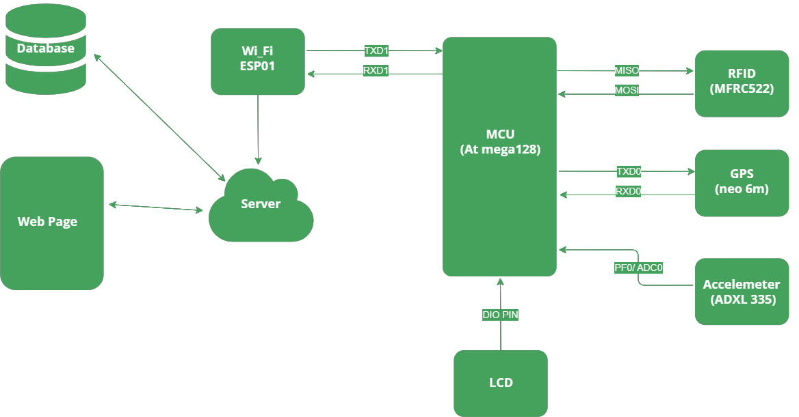As shown in Figure 1, our system incorporates various components and their connections to ensure efficient functionality. At its core, a device equipped with a microcontroller unit (MCU) is utilized, featuring with sensors. Additionally, a Wi-Fi module is integrated into device to establish seamless communication with Users who interact with the system. User interface with the system through a website, which is hosted on a dedicated server. This website is connected to a database, where all the data about the school bus and parent's data is stored securely for easy access and management.

Figure 1: Block Diagram

# Communication Path

As shown in Figure 2, To facilitate real-time communication between various components of the bus school tracking system, we implemented a robust communication pathway leveraging the MQTT protocol. Below is a diagram illustrating the communication flow:

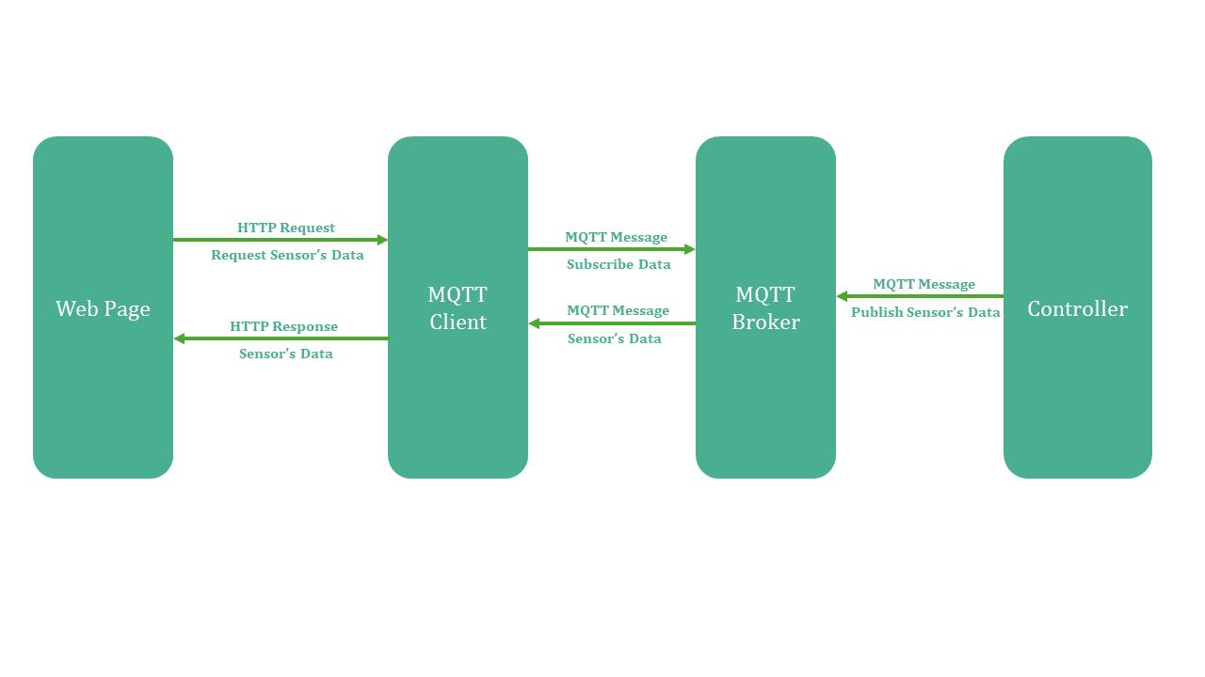

Figure 2: Communication Path

# System Architecture

The architecture in the Figure 3 is a typical layered embedded system architecture. Here’s a breakdown of the layers, from top to bottom:

* **Application Layer:** This layer refers to the software application that runs on the embedded system. It’s responsible for providing the end-user functionality.
* **Service Layer:** This layer provides services to the application layer. These services may include data processing or hardware interaction.
* **HAL (Hardware Abstraction Layer):** This layer provides an abstraction layer between the software and the hardware. It allows the upper layers to interact with the hardware without needing to know the specific details of the underlying hardware.
* **A screenshot of a computer program

  Description automatically generatedMCAL (Microcontroller Abstraction Layer):** This layer provides a low-level interface to the microcontroller’s peripherals. It allows the HAL to interact with the specific hardware components of the microcontroller.

Figure 3: System Architecture

# Deliverables

The System consists of two main parts these parts include:

# Hardware Package

The hardware package of the bus school tracking system includes an ATmega128 microcontroller, which manages tasks, receives sensor data, and communicates with the web server. The MFRC522 RFID sensor captures student attendance as they board and leave the bus, sending this data to the microcontroller. The NEO 6M GPS module tracks the bus's real-time location, providing updates to the microcontroller. The ADXL345 accelerometer detects sudden movements or accidents, transmitting this information for safety monitoring. A Wi-Fi module ensures wireless communication between the microcontroller and the web server, enabling real-time data transmission and updates. Together, these components enable comprehensive monitoring and safety of the school bus system, with the microcontroller acting as the central hub, processing and sending sensor data to the web server for access by parents, IT managers, and administrators.

# Software Package

The software package of the bus school tracking system is built around FreeRTOS for task scheduling, multitasking, and synchronization using semaphores, mutexes, and event handling. The system employs the MQTT protocol for real-time communication between the embedded system and the web server. The web application, developed for parents, IT managers, and administrators, facilitates various functions: managing user roles, student attendance, and monitoring accelerometer readings. Data from the sensors is transmitted via MQTT to the server, where it is processed and displayed on the web interface for real-time monitoring and management.

# Entity-Relation Diagram (ERD)

Refer to Figure 4 for the Entity-Relationship Diagram (ERD) that illustrates the structure and relationships of the various entities in our project. The ERD provides a visual representation of how different entities such as students, parents and admins are interconnected, enabling a comprehensive understanding of the data flow and interactions within the system. This diagram serves as a valuable reference for designing and implementing the project, ensuring a well-organized and efficient Bus Tracking system.

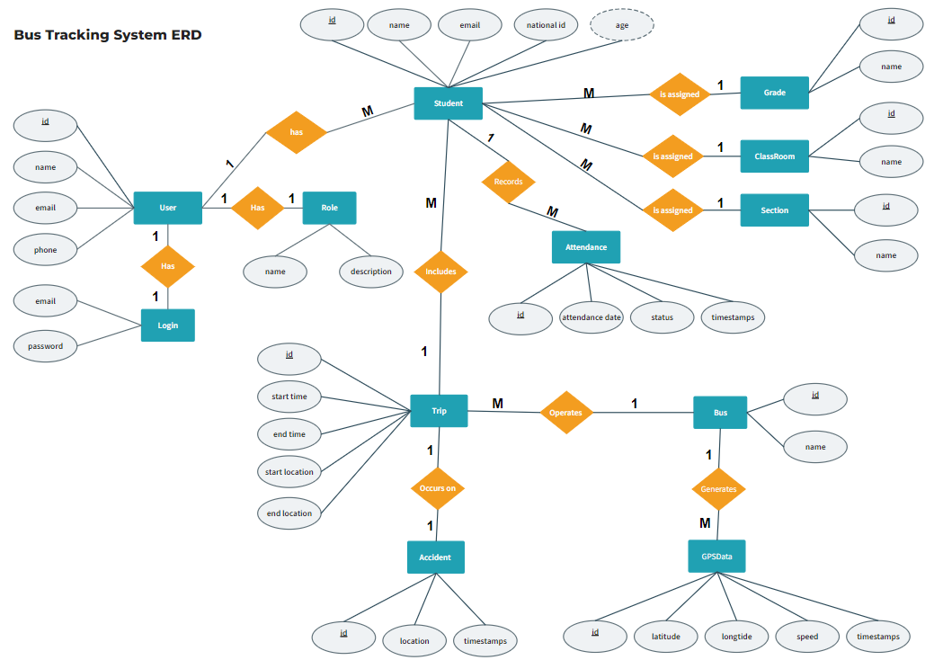

Figure 4: Entity Relationship Diagram (ERD)

# Relational Model

The relational model, depicted in Figure 5, showcases the logical structure of our project's database, illustrating the tables, attributes, and relationships between them. This model is essential for understanding the organization and storage of data within the system. By following the relational model, we ensure data integrity, efficient data retrieval, and effective management of information across the project. The relational model serves as a blueprint for designing and implementing the database, enabling seamless data manipulation and retrieval for bus tracking system.

Figure 5: Relational Model

# Use-Case Diagram

The Use Case Diagram, presented in Figure 6, provides a visual representation of the interactions between different actors and the system in our project. It highlights the various use cases, or functionalities, of the system and how they are accessed by different actors such as Manager, Admins, and Parents. This diagram helps in understanding the overall system behavior, identifying user requirements, and guiding the development process. By referring to the Use Case Diagram, we ensure that the project fulfils the needs of different actors and facilitates smooth communication and interaction within the bus tracking system.

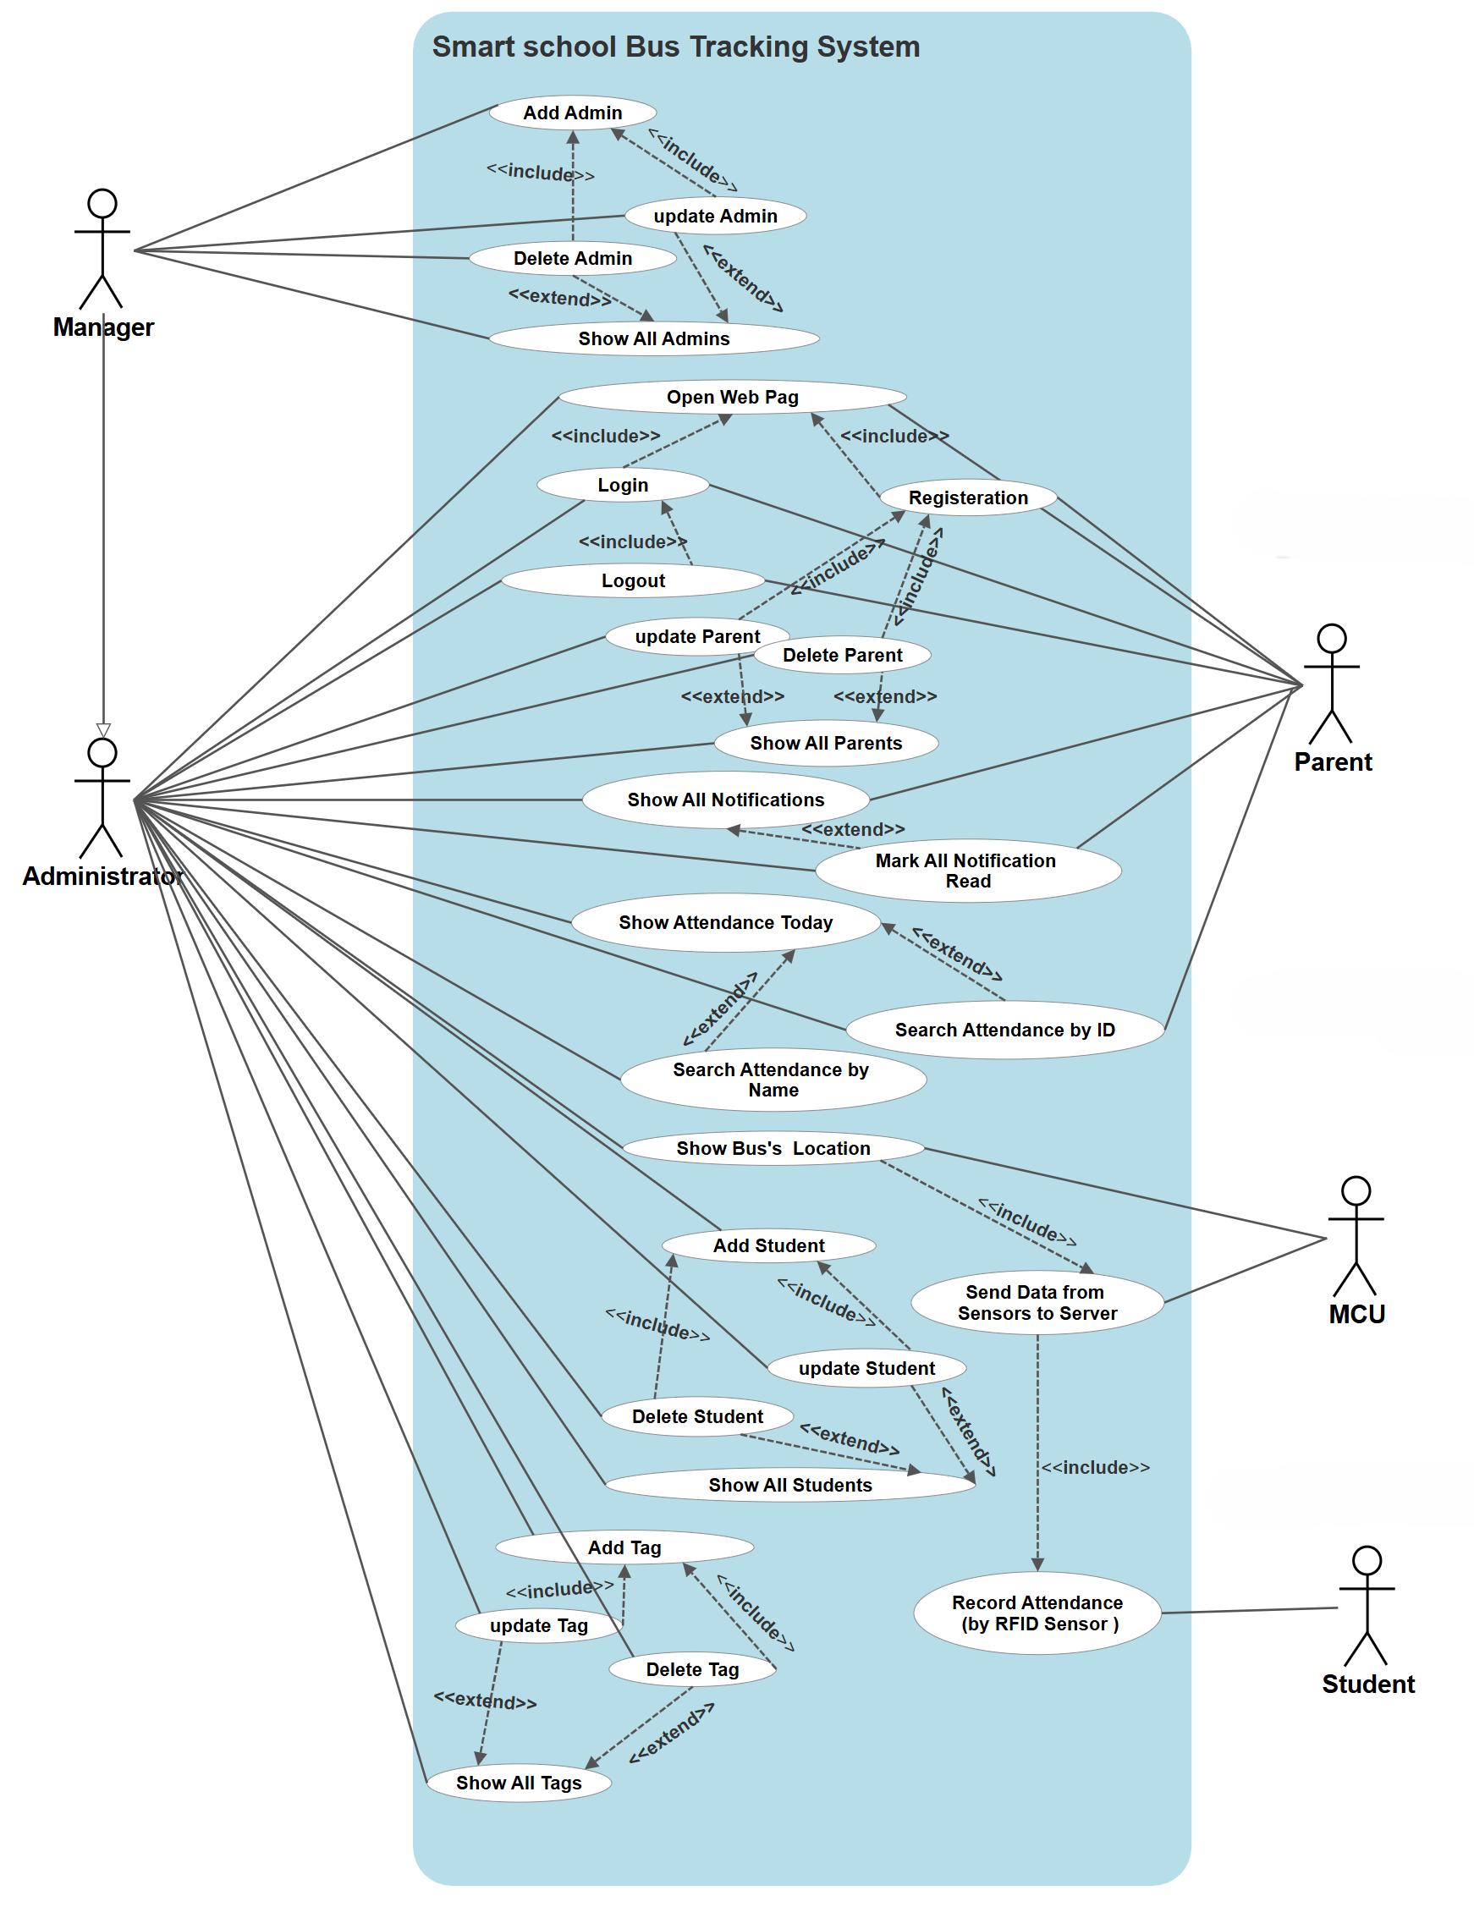

Figure 6: Use-Case Diagram

# Sequence Diagram

The project encompasses three Sequence Diagrams, each representing the interaction between a specific role and the system. Figure 7 illustrates the Sequence Diagram for IT-Manager, showcasing actions such as accessing (student, admin, parent) information and monitor sensor readings Figure 8 presents the Sequence Diagram for administrators, outlining tasks accessing (parent, student) information and monitor sensor readings. The parent interaction with the system is depicted in Figure 9, highlighting actions related to system as monitoring his son's data (attendance, bus location, any alerts).

# Sequence Diagram (IT-Manager)

Figure 7: Sequence Diagram (IT-Manager)

# Sequence Diagram (Administrator)

Figure 8: Sequence Diagram (Administrator)

# Sequence Diagram (Parent)

Figure 9: Sequence Diagram (Parent)

**Chapter 5**

**Tools & Technologies**

# Embedded Systems

An embedded system is a microprocessor-based computer hardware system with software that is designed to perform a dedicated function, either as an independent system or as a part of a large system. At the core is an integrated circuit designed to carry out computation for real-time operations. Complexities range from a single microcontroller to a suite of processors with connected peripherals and networks, from no user interface to complex graphical user interfaces. The complexity of an embedded system varies significantly depending on the task for which it is designed.

An embedded system has three components: Hardware, application software and Real Time Operating system (RTOS) that supervises the application software and provide mechanism to let the processor run a process as per scheduling by following a plan to control the latencies. RTOS defines the way the system works. It sets the rules during the execution of application program. A small-scale embedded system may not have RTOS.

# Software Tools

Software tools consists of three main parts: Website Tools, IOT Protocols and Techniques and FreeRTOS Opearting System.

# Website Tools

We used many website tools to build our website effectively as:

# Hyper Text Markup Language (HTML)

HTML (Hypertext Markup Language) is a fundamental language for building web pages. It serves as the backbone of the internet, enabling the creation of visually engaging and interactive content. With its simple and intuitive syntax, HTML provides a structured framework for organizing information, incorporating multimedia elements, and establishing meaningful connections through hyperlinks.

HTML is a coding language that developers use to create web pages. They can use HTML tags and attributes to decide how the pages will look and work on different devices and web browsers. HTML is very versatile and widely used by designers and developers. It helps them make websites that are appealing and easy to use. Whether it's a personal blog, an online store, or an informative site, HTML's flexibility and accessibility are incredibly valuable. It lets developers organize content and make links that allow users to move around websites and find information easily. HTML is like the building blocks of the internet, making it possible to create beautiful and interactive online experiences that grab people's attention.

# Cascading Style Sheet (CSS)

CSS (Cascading Style Sheets) is a key element in creating visually appealing web pages. It enhances the user experience by defining the look and layout of HTML elements. With CSS, designers have the power to customize typography, colors, backgrounds, borders, and more. By using selectors and properties, they can precisely control the appearance of each element, creating visually stunning websites that effectively convey a brand's identity. CSS's modular nature and cascading principles make it easy to maintain consistent styles across multiple pages, resulting in a cohesive and professional website.

Moreover, CSS embraces responsive design, allowing content to adapt to different screen sizes and devices. This flexibility ensures an optimal viewing experience for users on desktops, tablets, and smartphones. By harnessing CSS's capabilities, designers and developers can transform plain HTML structures into visually captivating and engaging web experiences. CSS is an essential component in the ever-evolving world of web development, enabling the creation of immersive and appealing interfaces that leave a lasting impression on users.

# JavaScript Language

JavaScript is a powerful programming language used to make web pages interactive. It allows developers to add functionality, respond to user actions, and change the appearance of web elements in real-time. With JavaScript, you can create dynamic forms, image sliders, and other interactive elements. It also enables data validation, form handling, and communication with servers to retrieve dynamic content. JavaScript makes web applications responsive and engaging by responding to user clicks, scrolls, and keystrokes. It is widely used in frameworks like React, Angular, and Vue.js to build complex and interactive web applications. JavaScript brings interactivity and life to the web.

# React-JS Framework

React (also known as React.js or ReactJS) is a free and open-source front-end JavaScript library for building user interfaces based on components by Facebook Inc. It is maintained by Meta (formerly Facebook) and a community of individual developers and companies. React can be used to develop single-page, mobile, or server-rendered applications with frameworks like Next.js. Because React is only concerned with the user interface and rendering components to the DOM, React applications often rely on libraries for routing and other client-side functionality.

A key advantage of React is that it only retenders those parts of the page that have changed, avoiding unnecessary retendering of unchanged DOM elements.

# Bootstrap Framework

Bootstrap (formerly Twitter Bootstrap) is a free and open-source CSS framework directed at responsive, mobile-first front-end web development. It contains HTML, CSS and (optionally) JavaScript-based design templates for typography, forms, buttons, navigation, and other interface components. As of May 2023, Bootstrap is the 17th most starred project (4th most starred library) on GitHub, with over 164,000 stars. [According to W3Techs, Bootstrap is used by 19.2% of all websites].

# Leaflet (software)

Leaflet is a JavaScript library used to build web mapping applications. It allows developers without a GIS background to display tiled web maps hosted on a public server, with optional tiled overlays. It can load feature data from GeoJSON files, style it and create interactive layers, such as markers with popups when clicked.First released in 2011,it supports most mobile and desktop platforms, supporting HTML5 and CSS3. Among its users are FourSquare, Pinterest, Flickr, and the USGS. Leaflet is open source, and is developed by Volodymyr Agafonkin, who joined Mapbox in 2013.

# JSON

JSON (JavaScript Object Notation) is a lightweight and widely used data format for storing and exchanging information. It provides a simple and human-readable way to represent structured data using key-value pairs. JSON is easy to understand and work with, making it a popular choice for data storage and communication in web applications. It supports various data types such as strings, numbers, Booleans, arrays, and objects. JSON is supported by many programming languages and can be easily parsed and generated. It is commonly used for APIs, configuration files, and data exchange between client and server. JSON's simplicity and versatility make it an essential tool for organizing and transmitting data in a standardized and efficient manner.

# Database- MYSQL

MySQL is a widely used and user-friendly database system for storing and managing structured data. It's popular in web applications and offers efficient data storage and retrieval. With MySQL, you can easily create, update, and query databases using a simple SQL language. It is known for its stability, scalability, and performance, making it reliable for handling large amounts of data. We integrated MySQL into our web application to allow real- time access and updates of bus location and attendance recording, improving bus monitoring.

MySQL provides a robust solution for managing data, whether it's a small website or a large-scale application. It offers advanced features like transactions, indexes, and stored procedures for handling complex database operations. Its simplicity and reliability make it an essential tool for organizations seeking efficient and secure data management solutions.

# PHP

PHP, or Hypertext Preprocessor, is an open-source scripting language that has become a cornerstone of web development since its inception in 1995. Designed for server-side scripting, PHP enables the creation of dynamic web pages and robust backend systems. Its versatility and ease of integration with various databases and web servers have made it a preferred choice for developers worldwide. A significant advantage of PHP is its extensive support for databases. It offers built-in support for various database systems, including MySQL, PostgreSQL, SQLite, and many others. This enables developers to execute SQL queries, retrieve and manipulate data, and perform complex database operations with ease. The PHP Data Objects (PDO) extension provides a consistent interface for database interactions, promoting security and flexibility in data handling.

# Laravel Framework

Laravel is a powerful and elegant PHP framework designed for web application development. Since its release in 2011, it has become popular due to its expressive syntax, comprehensive toolset, and emphasis on developer productivity. Laravel simplifies common tasks like routing, authentication, and caching, making it an ideal choice for both novice and experienced developers. Laravel follows the Model-View-Controller (MVC) pattern, promoting separation of concerns and code maintainability. Its routing system is flexible and supports RESTful APIs, while the built-in authentication system provides user registration, login, and password reset functionalities out of the box. With robust event handling, real-time communication support through Laravel Echo, and comprehensive testing capabilities using PHP Unit, Laravel ensures scalable, maintainable, and high-performing web applications. Its developer-friendly features make it a leading choice for modern web development.

# XAMPP

XAMPP is a free and open-source cross-platform web server solution stack package developed by Apache Friends, consisting mainly of the Apache HTTP Server, MariaDB database, and interpreters for scripts written in the PHP and Perl programming languages. Since most actual web server deployments use the same components as XAMPP, it makes transitioning from a local test server to a live server possible.

# Postman (software)

Postman is a global software company that offers an API platform for developers to design, build, test, and collaborate on APIs.

Over 30 million registered users and 500,000 organizations are using Postman. Postman also maintains the Postman API Network, a directory of over 100,000 public APIs that is listed as the world’s largest such collection. The company is headquartered in San Francisco and maintains additional offices in Tokyo and Bangalore, where Postman was founded.

# IOT Protocols and Techniques

# Hyper-Text Transfer Protocol (HTTP)

* + - * + It’s an application-layer protocol for transmitting hypermedia documents, such as HTML.
        + It was designed for communication between web browsers and web servers.
        + HTTP follows a classical client-server model, with a client opening a connection to make a request, then waiting until it receives a response.
        + HTTP is a stateless protocol, meaning that the server does not keep any data (state) between two requests.

So, we used HTTP GET requests to retrieve data from the server, such as Parent information or sensor readings, and we used HTTP POST requests to send data to the server, such as users’ inputs or control commands for the system.

# Message Queuing Telemetry Transport protocol (MQTT)

MQTT, an OASIS standard messaging protocol for the Internet of Things (IoT), serves as an exceptionally lightweight publish/subscribe messaging transport. With its small code footprint and minimal network bandwidth requirements, MQTT is an ideal choice for connecting remote devices across various industries like automotive, manufacturing, telecommunications, and oil and gas. The protocol's clients are incredibly compact and demand minimal resources, making them suitable for deployment on small microcontrollers. MQTT enables seamless messaging between device and cloud, as well as cloud to device, facilitating real-time data exchange.

In our case, MQTT played a crucial role in transmitting sensor readings, such as RFID scanning tag, any sudden accident or accelerometer and bus location from the controller to the server, enabling seamless communication and facilitating the transmission of sensor data.

# PubSubClient Library

The **PubSubClient** library is a powerful **MQTT** client library that provides a simple and easy-to-use interface for communicating with an **MQTT** broker. With this library, it becomes very easy to connect to a broker, publish messages to specific topics, and subscribe to topics to receive messages.

One of the key functions of the **PubSubClient** library is the **publish()** function. This function is used to publish messages to a specific topic on the **MQTT** broker. It takes two arguments: the topic to publish to, and the message to send. When this function is called, it sends the message to the broker, which then distributes it to all subscribers listening to that topic. This enables clients to communicate with each other and exchange information in real-time.

In addition to publishing messages, the **PubSubClient** library also provides a powerful subscription mechanism through the **subscribe()** function. This function is used to subscribe to a specific topic on the broker. Once subscribed, the client can receive all messages published to that topic. This allows clients to stay informed about events happening in the system and respond accordingly.

# Free RTOS

In our project, FreeRTOS is used as the real-time operating system to manage task scheduling and synchronization. It enables multitasking by allowing multiple tasks to run concurrently, ensuring efficient use of system resources.

# Concurrency and Multi-tasking

Multi-tasking is a level of concurrency.

True Concurrent execution: Two or more tasks being executed at the same time. Figure 10 shows three tasks (Task 1, Task 2, Task3) running concurrently over time.

Figure 10: True Concurrent Execution

Pseudo Concurrent execution: In contrast, concurrency is depicted in Figure 11, where only one task executes at any given moment. The system switches rapidly between tasks (Task 1, Task 2, Task 3), giving the illusion that they are running simultaneously. This switching allows multiple tasks to progress without any one task monopolizing the CPU.

Figure 11: Pseudo Concurrent Execution

**Why we need Multi-tasking:**

* I/O devices are usually very slow.
* While one task is waiting for the I/O operation, other tasks can execute.
* Tasks can be scheduled so that slower blocking jobs are handled by lower priority tasks, while faster more time critical tasks are given more CPU time.

# Kernel:

Kernel as shown in Figure 12 the main part of OS that manages task execution and communication between task.

Figure 12: Kernel Structure

# Scheduler:

Scheduler is the part of kernel that is responsible for task execution based on Scheduling algorithm like task priorities.

Preemptive Priority-based Scheduler: In preemptive scheduling, the operating system can interrupt a low priority task to start a high priority task as shown in Figure 13.

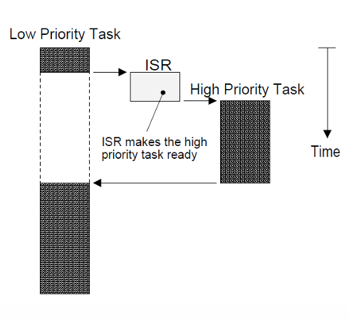

Figure 13: Preemptive Scheduler

Non-Preemptive Priority-based Scheduler: In non-preemptive scheduling, the operating system cannot interrupt a running task until it voluntarily relinquishes the CPU as shown in Figure 14.

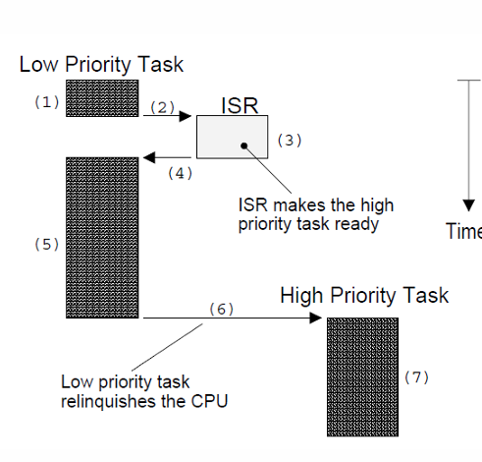

Figure 14: Non-Preemptive Scheduler

# Task States

Task states are classified primarily into the five below.

Dormant: The DORMANT state corresponds to a task that resides in memory but has not been made available to the multitasking kernel.

Ready State: A task is READY when it can be executed but its priority is less than that of the task currently being run. In this state, the task actively competes with all other ready tasks for the processor's execution time.

Running State: A task is RUNNING when it has control of the CPU and it's currently being executed.

Waiting State: A task is WAITING when it requires the occurrence of an event (waiting for an I/O operation to complete, a shared resource to be available, a timing pulse to occur, time to expire, etc.).

ISR (Interrupt Service Routine): A task is in ISR state when an interrupt has occurred and the CPU is in the process of servicing the interrupt.

Figure 15: Task States

# Inter-Task Communication & Synchronization

The simplest way to make the tasks to communicate and interact with each other through shared resources.

Each tasks must access the shared resource exclusively, in order not to allow conflict to occur between tasks, and this is called mutual exclusion.

RTOS offer services to handle two issues which impact

real time application greatly, this two issues are:

* Mutual Exclusion
* Synchronization

Provided Solution for this issues is Semaphores.

**Semaphores:**

a Semaphore is a variable or abstract data type that provides a simple but useful abstraction for controlling access by multiple processes parallel programming to a common resource in a environment.

Figure 16: Semaphore

But semaphore can cause a problem called priority inversion.

**Priority Inversion:**

Shared resources cause a new and subtle scheduling problem: a low-priority process blocks the execution of a higher-priority process by keeping hold of its resource, a phenomenon known as priority inversion.

Figure 17: Priority Inversion

**Mutex:**

Mutex uses a priority inheritance mechanism to avoid priority inversion issues. The priority inheritance mechanism keeps higher-priority processes in the blocked state for the minimum possible time. However, this cannot avoid the priority inversion problem, but it can reduce its effect up to an extent.

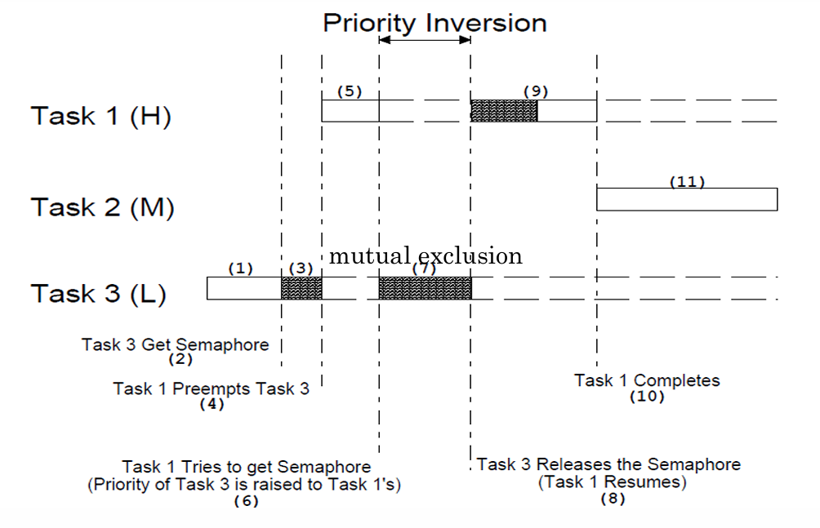

Figure 18: Priority Inheritance

# Hardware Tools

We used many Hardware components to build our system effectively as:

# ATMEGA128 (MCU)

The ATmega128 is a powerful 8-bit microcontroller from Atmel's AVR family, widely used in embedded systems and applications requiring precise control and efficient processing. It features an 8-bit RISC architecture that delivers 1 MIPS per MHz, enabling optimal power consumption and processing speed. The microcontroller includes 128KB of In-System Programmable Flash with Read-While-Write capabilities, 4KB of EEPROM, and 4KB of internal SRAM. It offers 53 programmable I/O lines, and supports multiple communication interfaces such as USART, SPI, and TWI. Additionally, it is equipped with four 8-bit and two 16-bit timers/counters, a real-time clock with a separate oscillator, an 8-channel 10-bit ADC, and an analog comparator.

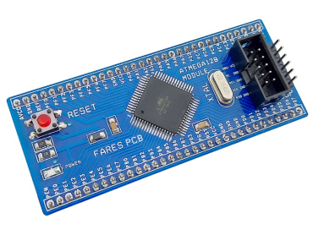

Figure 19: ATMega128

**Why We use ATMega128 not ATMega32:**

The ATmega128 microcontroller was chosen for our graduation project primarily because it meets our requirement for having multiple UART (Universal Asynchronous Receiver/Transmitter) interfaces. Unlike the ATmega32, which only has a single UART, the ATmega128 offers two UARTs, allowing us to handle multiple serial communication channels simultaneously. This capability is essential for our project, which involves interfacing with multiple serial devices. Additionally, the ATmega128 provides enhanced memory capacity, more I/O lines, and additional features like multiple timers and power-saving modes, making it a robust and versatile choice for complex embedded applications. Its extended functionality ensures that our project can accommodate future expansions and additional features without significant hardware changes.

# ESP-01 (WI-FI Module)

The Wi-Fi module ESP01, shown in Figure 15, is an essential component of our school bus tracking system. This module enables wireless connectivity for the tracking device installed on each school bus, allowing it to receive and transmit location data over the IoT network. With the help of the Wi-Fi module, we can facilitate real-time tracking and monitoring of the school buses, providing parents and school administrators with accurate and timely information about the buses' locations. This enhances the safety and security of the students, ensuring that parents are informed of their children's whereabouts during their commute. The ESP01 module has proven to be an effective and reliable means to establish wireless connectivity, making it a critical component of our school bus tracking system.

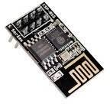

Figure 20: ESP-01 (Wi-Fi Module)

**Pin Description:**

* **VCC**: This pin needs to be connected to a 3.3V power supply. The ESP-01 operates at 3.3V, and applying higher voltages can damage the module.
* **GND**: This is the ground pin and should be connected to the ground of your power supply.
* **TX/RX**: These pins are used for serial communication. Connect TX of the ESP-01 to RX of the microcontroller and RX of the ESP-01 to TX of the microcontroller. Remember to use a level shifter if your microcontroller operates at 5V logic.
* **CH_PD**: This pin must be connected to 3.3V to enable the ESP-01 module.
* **RST**: This pin can be connected to a push-button to manually reset the module.
* **GPIO0/GPIO2**: These pins can be used as general-purpose I/O pins. GPIO0 is also used for selecting the boot mode:
  + Normal boot mode: GPIO0 should be pulled high (to 3.3V).
  + Firmware flashing mode: GPIO0 should be pulled low (to GND) during power-up or reset.[6] 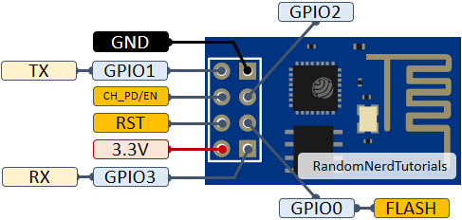

Figure 21: ESP-01 Description

# 5.3.3 Accelerometer sensor (ADXL345)

The ADXL345 is a compact, low-power, 3-axis accelerometer sensor designed for high-resolution measurement of static and dynamic acceleration. Widely used in various applications, the ADXL345 is a critical component in our school bus tracking system. Its ability to detect motion and orientation makes it ideal for monitoring the bus's movement and ensuring the safety of the students on board.

|  |
| --- |
|  |
| C:\Users\Yossri\AppData\Local\Temp\ksohtml9428\wps3.png  Figure 22: ADXL-345 (Accelerometer) |  |

|  |
| --- |
|  |
| C:\Users\Yossri\AppData\Local\Temp\ksohtml9428\wps4.jpg  Figure 23: ADXL-345 Hardware Component |  |

**Pin Description:**

* VCC (Pin 1): This pin provides the power supply to the sensor. The ADXL345 operates with a supply voltage range from 2.0V to 3.6V.
* GND (Pin 2): This pin is connected to the ground of the system.
* CS (Pin 3): This pin selects the communication mode. When connected to GND, the sensor operates in I2C mode. When connected to VCC, the sensor operates in SPI mode.
* INT1 (Pin 4): This pin is used to signal an interrupt event. It can be programmed to trigger on different conditions such as data ready, single tap, double tap, activity, inactivity, and free-fall.
* INT2 (Pin 5): This pin functions similarly to INT1 and can be programmed for various interrupt conditions.
* SDA/SDI/SDIO (Pin 6): In I2C mode, this pin functions as the data line (SDA). In SPI 4-wire mode, it functions as the data input (SDI). In SPI 3-wire mode, it functions as a bi-directional data line (SDIO).
* SCL/SCLK (Pin 7): In I2C mode, this pin functions as the clock line (SCL). In SPI mode, it functions as the clock line (SCLK).
* SDO/ALT ADDRESS (Pin 8) : In SPI mode, this pin functions as the data output (SDO). In I2C mode, it determines the alternate address of the device. Connecting this pin to GND sets the I2C address to 0x53, while connecting it to VCC sets the address to 0x1D.

**How does it work?**

The ADXL345 operates by measuring the acceleration forces acting on it. These forces can be static, like gravity, or dynamic, such as those caused by movement or vibration. The sensor contains a microelectromechanical system (MEMS) that uses tiny movable structures to detect acceleration. When acceleration occurs, these structures shift, causing a change in capacitance. This change is converted into an electrical signal that represents the acceleration in the X, Y, and Z axes.

The ADXL345 communicates with the microcontroller via I2C or SPI interface, providing digital output for easy integration with various systems. It supports a wide range of data rates, from 0.1 Hz to 3200 Hz, and has user-selectable measurement ranges of ±2g, ±4g, ±8g, and ±16g, allowing for precise customization based on the requirement.

**Activity Mode**

The ADXL345 accelerometer can detect activity by comparing the acceleration on any axis to a predefined threshold. This allows it to determine if the device is in motion or at rest. When the acceleration exceeds the set threshold, the activity interrupt is triggered, indicating that movement has been detected. This feature is useful for applications that need to monitor motion and differentiate between active and inactive states.

**Free-Fall Mode**

The ADXL345 also includes a free-fall detection mode, which identifies when the device is in a free-fall state. This mode is activated when the acceleration on all axes falls below a predefined threshold for a specified duration. When this condition is met, the free-fall interrupt is triggered, signaling that the device is falling. This feature is particularly useful for applications that need to detect drops, such as for hard disk drive protection or mobile device safety features.

**It's Important:**

1. Motion Detection: Using the activity mode of the ADXL345, the system can detect when the bus is in motion and when it is idle. This can help in monitoring the bus's activity and ensuring it follows the planned route and schedule.

2. Free-Fall Detection: In case of an accident where the bus might experience free fall (e.g., falling off a road edge), the free-fall detection feature can trigger an emergency alert, notifying authorities and initiating a rapid response to ensure the safety of the students.

3. Sudden Braking or Acceleration: By monitoring the accelerometer data, the system can detect sudden braking or acceleration events, which could indicate potential safety issues or reckless driving. Alerts can be generated for review and necessary action.

4. Impact Detection: The high sensitivity and resolution of the ADXL345 can detect impacts or collisions, triggering alerts for immediate action. This can be critical for ensuring quick responses in case of accidents.

# 5.3.4 GPS Module (NEO6)

The NEO-6 GPS module is a highly popular and efficient GPS receiver developed by u-blox. It is designed to provide accurate location and time information by communicating with a network of global positioning satellites. This module is widely used in applications such as vehicle tracking, navigation systems, and timing systems. In our school bus tracking system, the NEO-6 module plays a crucial role in providing real-time location data, ensuring that the bus's route and position can be continuously monitored for safety and efficiency.[7]

# 

|  |
| --- |
|  |
| C:\Users\Yossri\AppData\Local\Temp\ksohtml9428\wps5.png  Figure 24: GPS Neo-6M |  |

**Pin Description:**

* VCC: This pin is used to supply power to the module. The typical operating voltage is 3.3V or 5V, depending on the specific module variant.
* GND: The ground pin, which should be connected to the ground of the power supply.
* TX: Transmit pin. This pin sends serial data from the GPS module to the microcontroller or other devices. The data includes location coordinates, time, and other GPS information.
* RX: Receive pin. This pin is used to receive commands from the microcontroller or other devices to configure the GPS module.
* PPS: Pulse Per Second pin. This pin outputs a pulse signal at a rate of one pulse per second, which is synchronized with the GPS time. It can be used for precise timing applications.
* Enable (EN): This pin can be used to enable or disable the GPS module. Pulling this pin low can put the module into a low-power state.

**How does it work?**

The NEO-6 GPS module works by receiving signals from multiple GPS satellites orbiting the Earth. These satellites continuously transmit their current position and time. The GPS module captures these signals and uses the time delay of the received signals to calculate the distance from each satellite. By triangulating the distances from at least four satellites, the module can determine its precise geographical location (latitude, longitude, and altitude) and the current time.

The NEO-6 module is equipped with a high-sensitivity GPS receiver, which allows it to acquire and track satellite signals even in challenging environments, such as urban areas or dense forests. It supports various positioning modes, including 2D and 3D fixes, and can provide updates at a rate of up to 5 Hz (5 updates per second), making it suitable for real-time tracking applications.

**NMEA Message Description:**

**GPGGA LOG:**

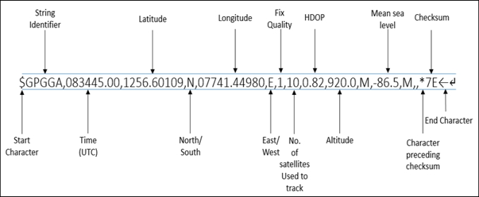

Figure 25: GPGGA LOG

# RFID (MFRC522)

The MFRC522 is an RFID (Radio Frequency Identification) module designed for contactless communication at 13.56 MHz It is widely used for identifying and tracking objects using RFID tags, which contain unique identification data. In our school bus tracking system, the MFRC522 module plays a crucial role in identifying students as they board and exit the bus, ensuring accurate attendance records and enhancing student safety.

|  |
| --- |
|  |
|  | C:\Users\Yossri\AppData\Local\Temp\ksohtml9428\wps10.jpg  Figure 26: RFID (MFRC522) |

**Pin Description:**

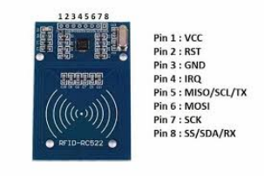

Figure 27: RFID (MFRC522) Description

|  |
| --- |
|  |
|  |  |
|  |  |

The MFRC522 module typically has 8 pins used for power, data communication, and control. Here is a detailed description of each pin:

* VCC: This pin provides the power supply to the module. The operating voltage is typically 3.3V.
* GND: This pin should be connected to the ground of the system.
* RST: This pin is used to reset the module. It can be connected to a GPIO pin on the microcontroller to reset the module programmatically.
* IRQ: This pin is used to signal an interrupt to the microcontroller when certain events occur (e.g., tag detection). It is optional and not always used in basic applications.
* MISO/SCL/TX: This pin serves multiple functions depending on the communication interface used. In SPI mode, it acts as MISO. In I2C mode, it acts as the clock line (SCL). In UART mode, it acts as the transmit line (TX).
* MOSI: In SPI mode, this pin is used for data sent from the microcontroller to the MFRC522.
* SCK: This pin provides the clock signal for the SPI communication.
* SS/SDA/RX: This pin serves multiple functions depending on the communication interface used. In SPI mode, it acts as the Slave Select (SS) pin. In I2C mode, it acts as the data line (SDA). In UART mode, it acts as the receive line (RX).

**How does it work?**

The MFRC522 module works by generating an electromagnetic field through its antenna. When an RFID tag comes into this field, it gets energized and sends back its unique identification data. The module then receives this data, decodes it, and sends it to the microcontroller for further processing.[9]

The RFID system consists of two main components:

1. RFID Reader (MFRC522 Module): This device generates the electromagnetic field and communicates with the RFID tags.
2. RFID Tag: A small chip with an antenna that contains unique identification data. When placed near the reader, it transmits this data back to the reader.

RFID tags are made of three pieces:

▪ A microchip (an integrated circuit which stores and processes information and modulates and demodulates radiofrequency

▪ An antenna for receiving and transmitting the signal.

|  |
| --- |
|  |
| ▪ A substrate. There are a variety of RFID tags on the market today, differentiated by frequency range (low, high and ultra-high). |  |

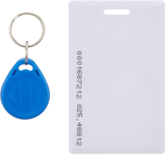

Figure 28: RFID Tag

# 5.3.6 LCD (16*4)

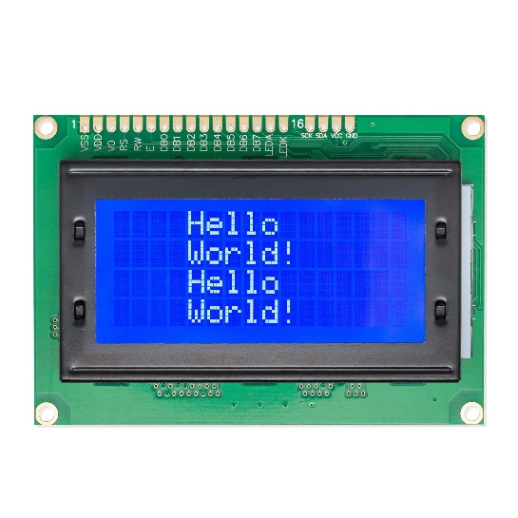LCD (Liquid Crystal Display) modules are widely used in various applications to display alphanumeric characters and custom characters. One of the most common types is the 16x4 LCD, which can display 16 characters per line on 2 lines.

Figure 29: LCD (Liquid Crystal Display)

**Pin Description for a 16x4 LCD Module**

A typical 16x2 LCD module has 16 pins, which are described as follows:

* **VSS** (Pin 1): Ground pin.
* **VDD** (Pin 2): Power supply pin. Typically connected to +5V.
* **VO** (Pin 3): Contrast adjustment pin. A potentiometer is usually connected between this pin, VDD, and GND to adjust the display contrast.
* **RS** (Pin 4): Register Select pin. Controls whether data is sent to the data register (RS=1) or instruction register (RS=0).
* **RW** (Pin 5): Read/Write pin. Controls whether the LCD is in read mode (RW=1) or write mode (RW=0).
* **E** (Pin 6): Enable pin. Initiates the data read/write process when pulsed high.
* **D0-D7** (Pins 7-14): Data pins. Used to send data or instructions to the LCD. In 4-bit mode, only D4-D7 are used.
* **A** (Pin 15): LED backlight anode. Connected to +5V through a current-limiting resistor.
* **K** (Pin 16): LED backlight cathode. Connected to GND.

**How an LCD Works**

LCD modules work by controlling the light passage through liquid crystals using electrical signals. Here’s a basic outline of how they operate:

1. **Power and Initialization**:
   * The LCD is powered by connecting VDD to +5V and VSS to GND. The contrast is adjusted using the VO pin.
   * Initialization sequences are sent to configure the LCD in either 4-bit or 8-bit mode.
2. **Register Selection**:
   * **RS pin**: Selects the register to send data to.
     + RS = 0: Command register. Used to send instructions like clear display, return home, etc.
     + RS = 1: Data register. Used to send data (characters) to be displayed.
3. **Read/Write Operations**:
   * **RW pin**: Determines the operation mode.
     + RW = 0: Write operation.
     + RW = 1: Read operation (rarely used in most applications).
   * **Enable (E) pin**: Activates the data/command transfer. Data is latched when the enable pin transitions from high to low.
4. **Data Transmission**:
   * **8-bit Mode**: All 8 data pins (D0-D7) are used. Faster but requires more I/O pins.
   * **4-bit Mode**: Only the upper 4 data pins (D4-D7) are used. Data is sent in two nibbles (4 bits at a time). Saves I/O pins but is slightly slower.

**Chapter 6**

**User Interface**

# Login and Sign Up

The first page that appears to the user in our website is the login page as in Figure 30, login process is an essential part of the system's functionality, which serves as the entry point for users. Upon accessing the website, second page is register if the user is not logged in depicted in Figure 31. Here, they can input their credentials to gain access to the system and begin utilizing its features.

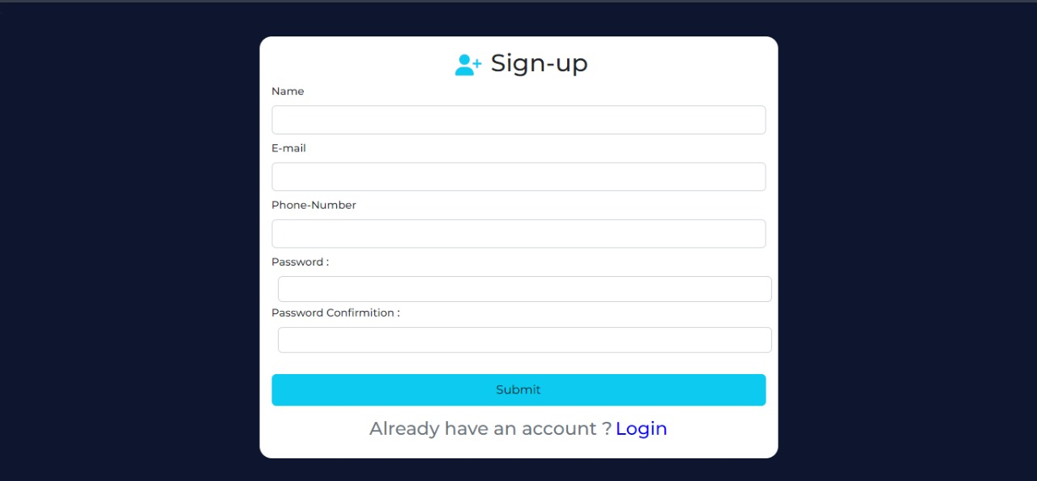

Figure 30: Website Login Page

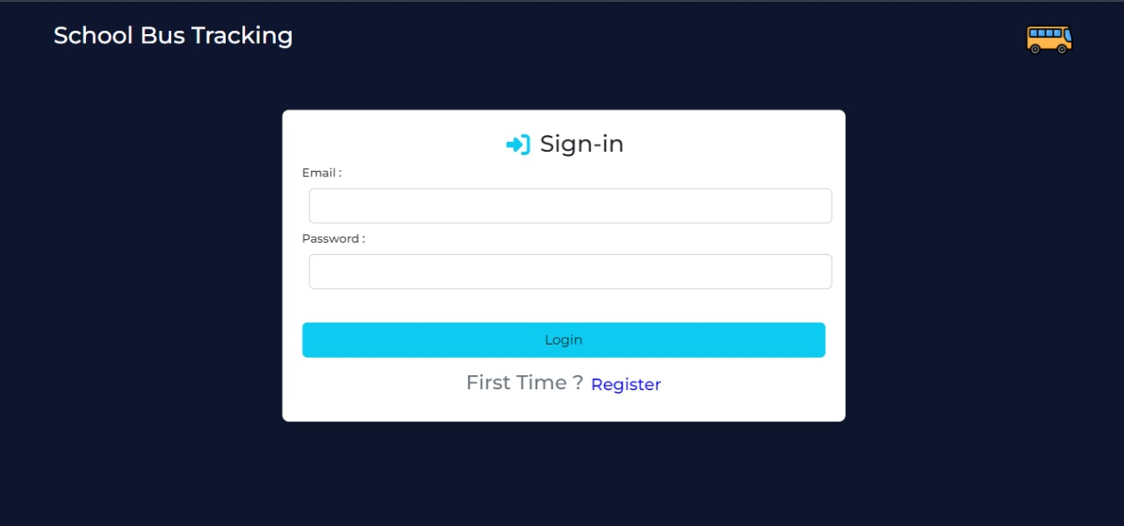

Figure 31: Website Signup Page

as in Figure 32, after sign up send otp to verify the email of the user

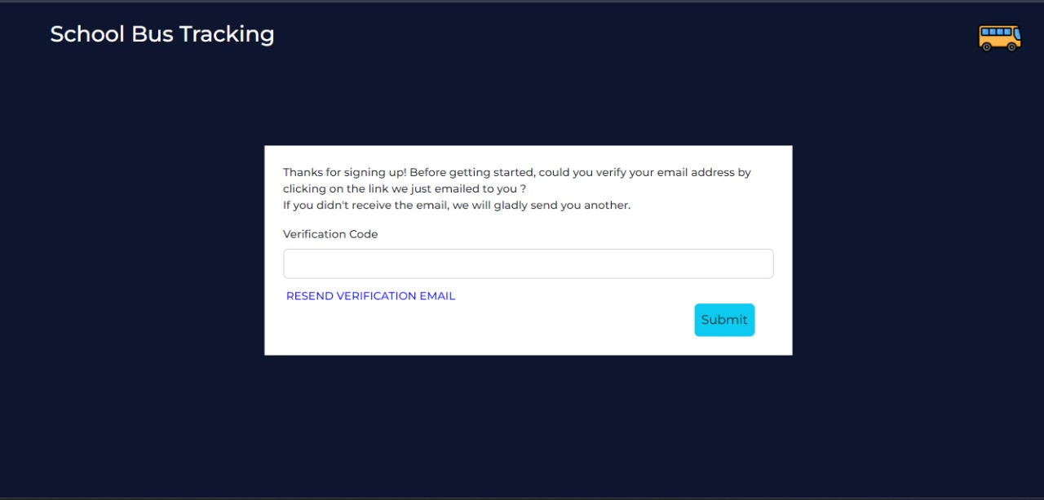

Figure 32: Verifying Page

# Admin

As shown in Figure 33, once logged in as an Admin, the software grants access to a range of features specific to their role. As the Admin, they are responsible for managing the data of all users in the system, including parents buses and students . After navigating through the website and utilizing the various functionalities, the Admin can log out, concluding their experience and ensuring the security of the system's data.

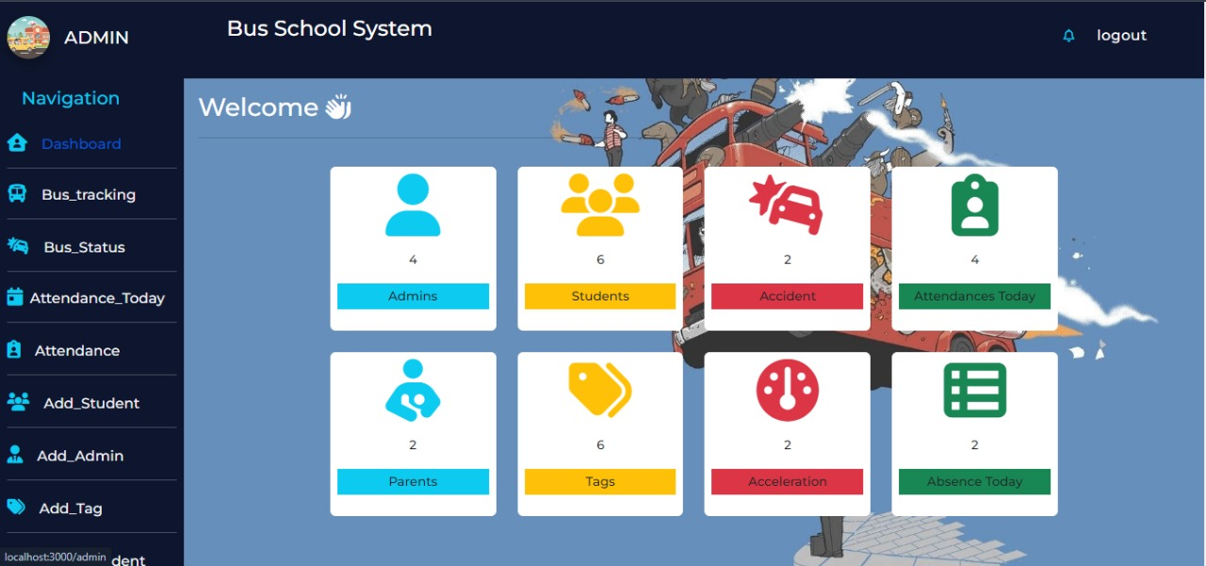

Figure 33: Admin Homepage

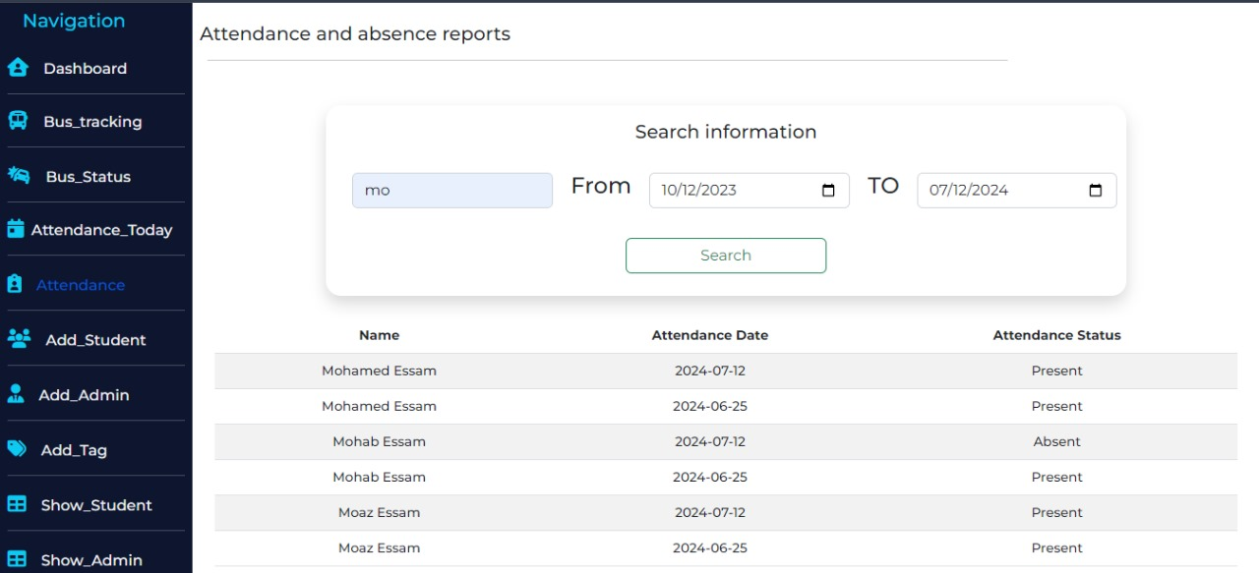As shown in Figure 34 , Figure 35, the Admin views some essential data of Students absence by this page and absence of today only

Figure 34: Student Attendance Data

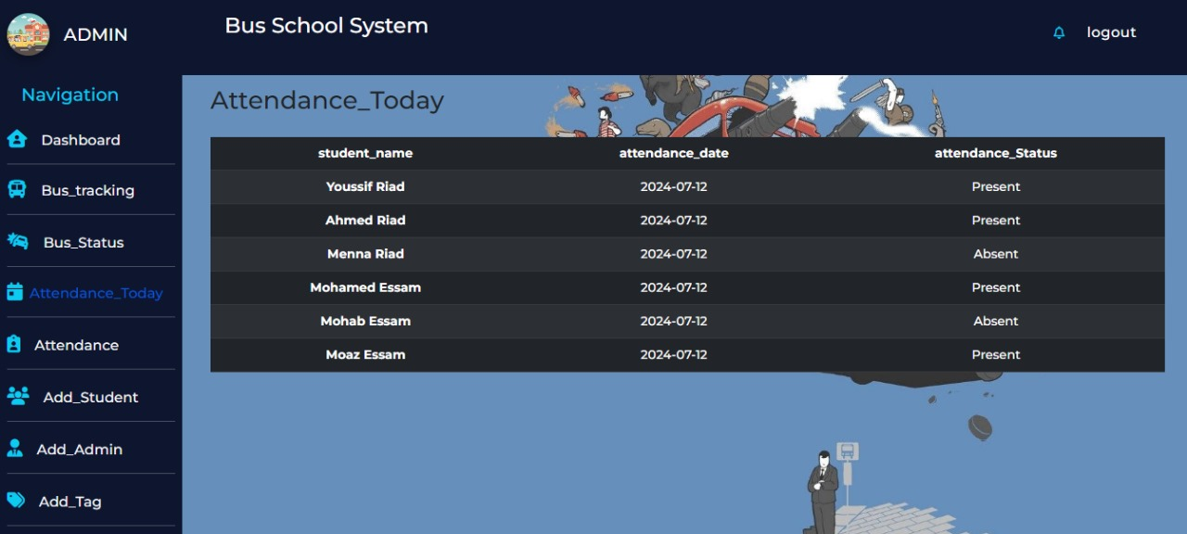

Figure 35: Student Absence Page

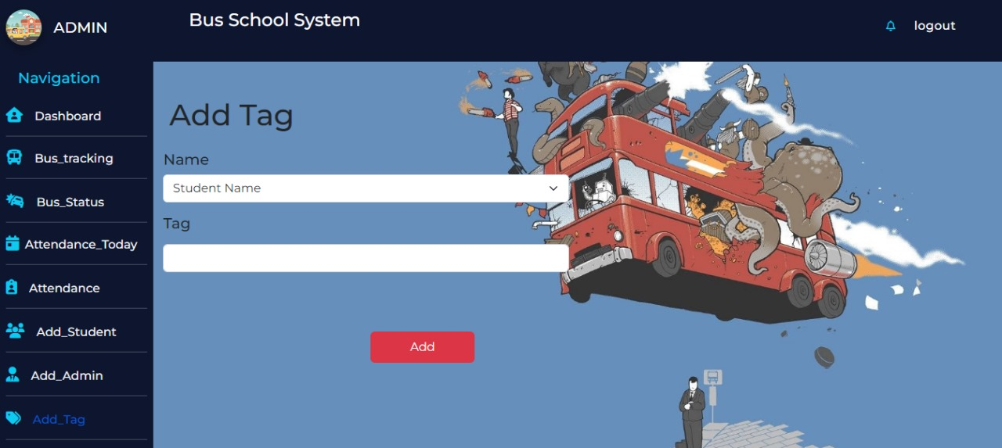As shown in Figure 36 ,37, the Admin can add another Tag or update by this form where it’s just asked tag ID and Name

Figure 36: Add Tag Page

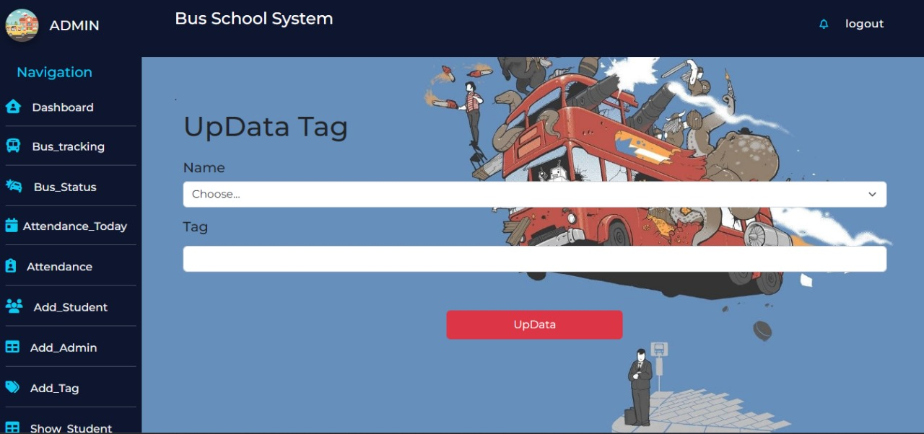

Figure 37: Update Tag Page

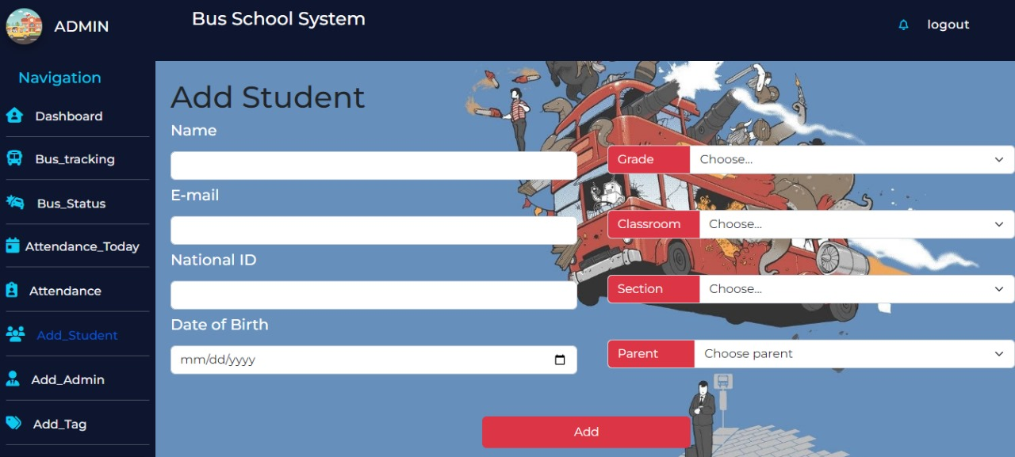As shown in Figure 38 , 39, the Admin can Add new Student or Update by taking some essential data like name ,email ,national Id

Figure 38: Add Student Page

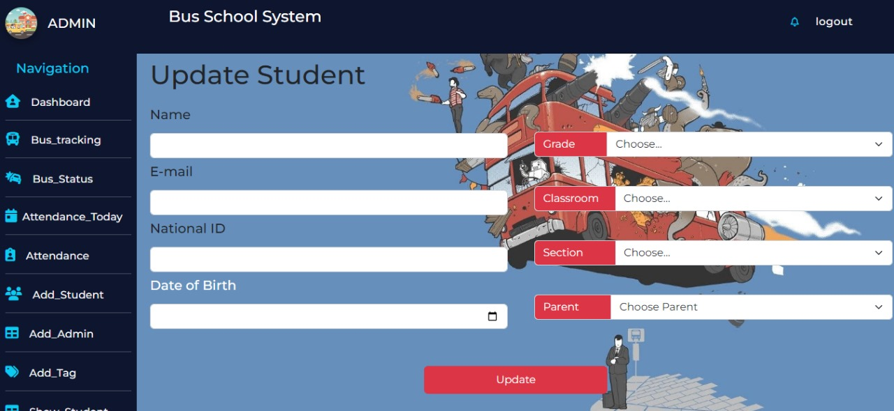

Figure 39: Update Student Page

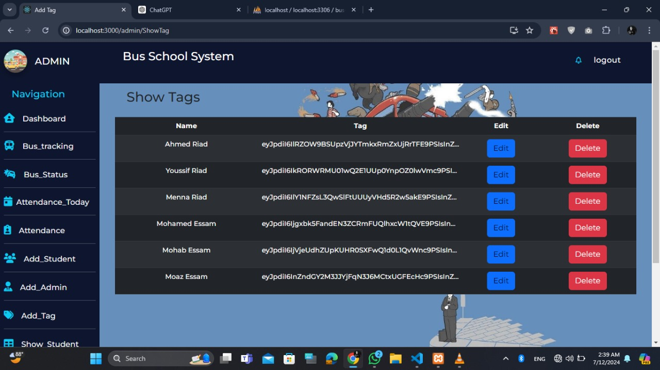As shown in Figure 40, the Admin can show all data of students liken name and their tag

Figure 40: Student Tags Page

As shown in Figure 41, the Admin can show all parent in the system and their information

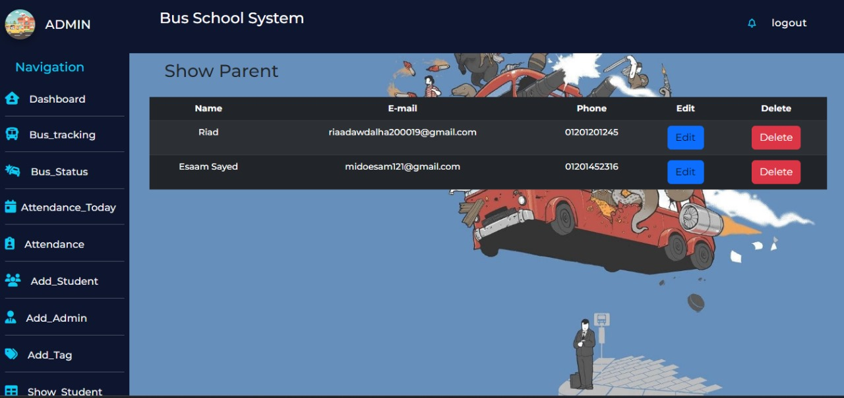

Figure 41: Parent Data Page

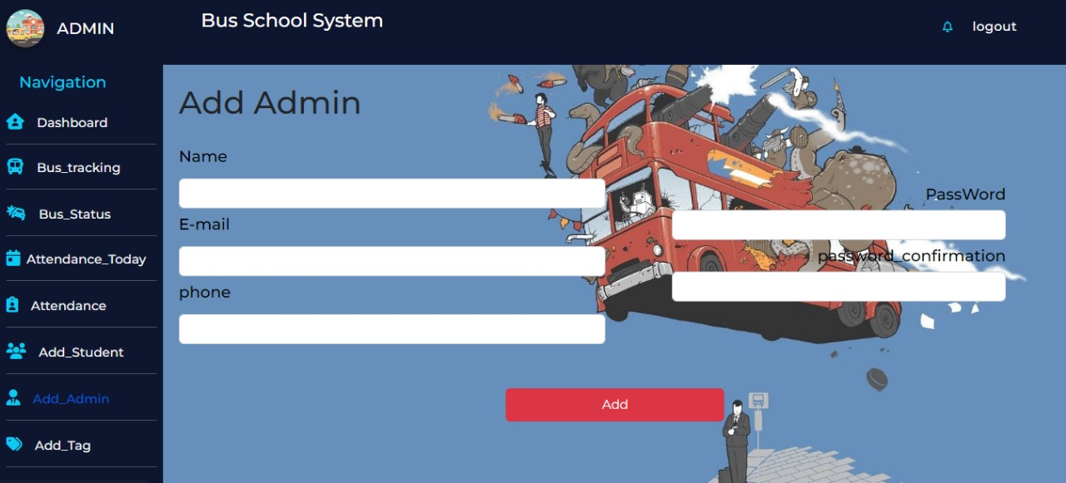As shown in Figure 42, the Admin can add another Admin to the system

Figure 42: Add Admin Page

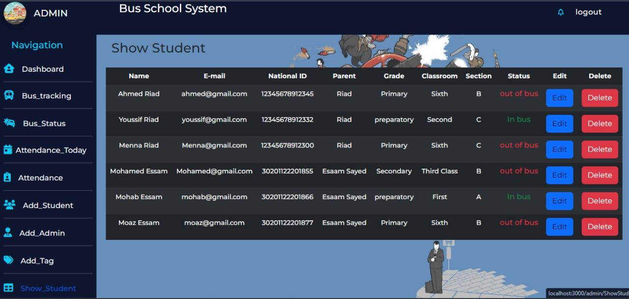As shown in Figure 43, the Admin views some essential data of Students by this page and their status out of bus or on bus

Figure 43: Status of Students Page

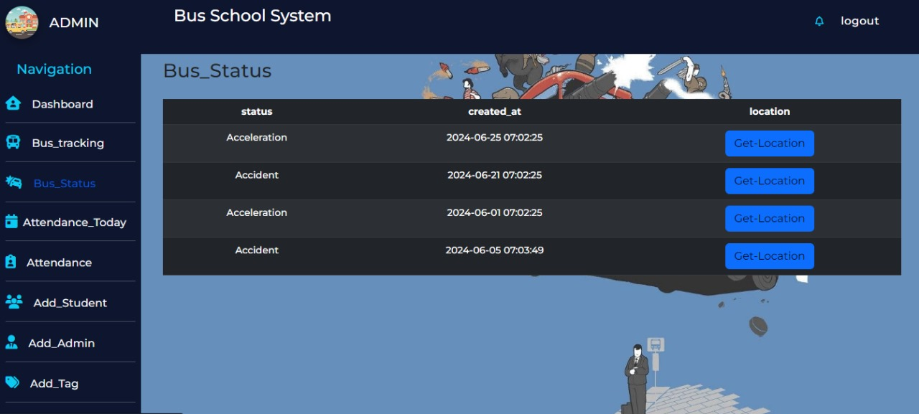As shown in Figure 44, the Admin can show bus status if the accident found or exceeds the speed and can get their location

Figure 44: Bus Status Page

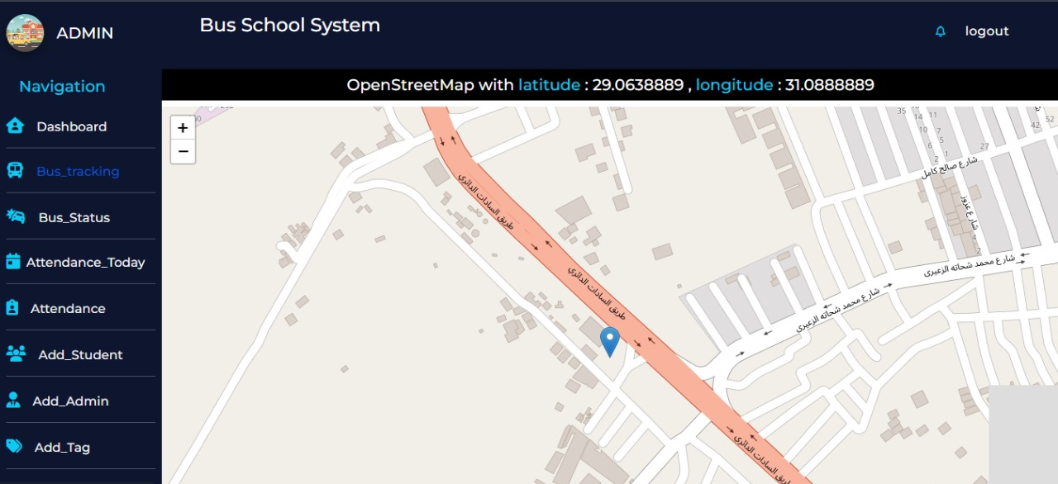As shown in Figure 45, the admin can get the bus real location

Figure 45: Bus Location Page

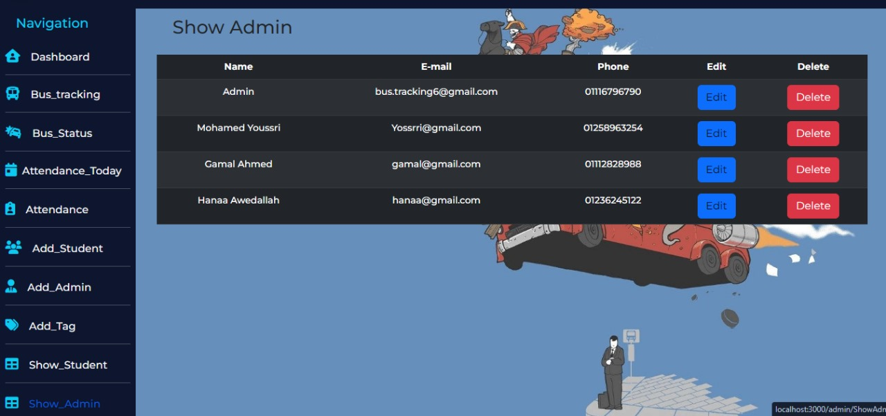As shown in Figure 46, the Admin can show all admins in the system.

Figure 46: Admin Data Page

# 6.4 Parent

As shown in Figure 47, if you logged as a parent you found the home page

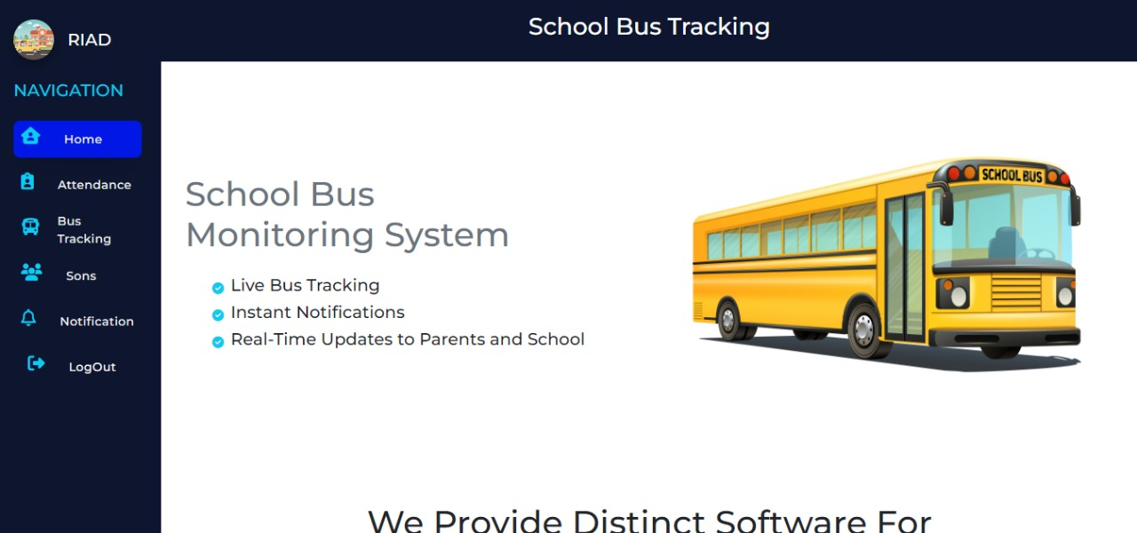

Figure 47: Parent Homepage

As shown in Figure 48, the parent can show more than one sons in the system and their status

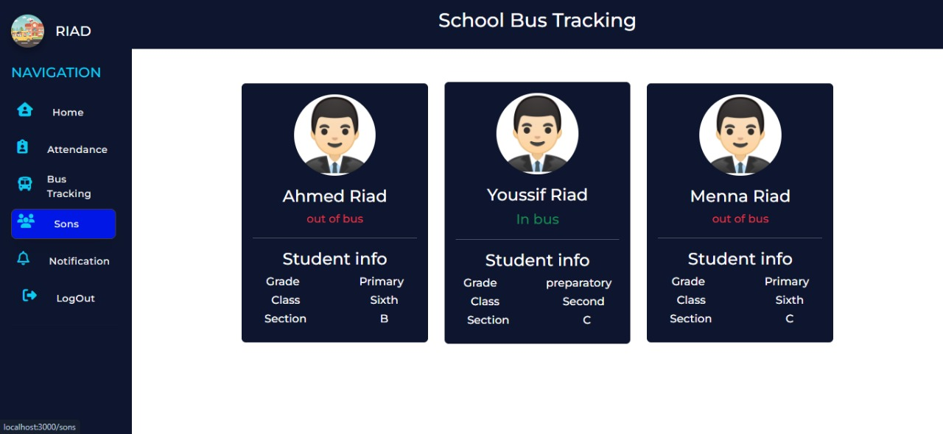

Figure 48: Sons Status Page

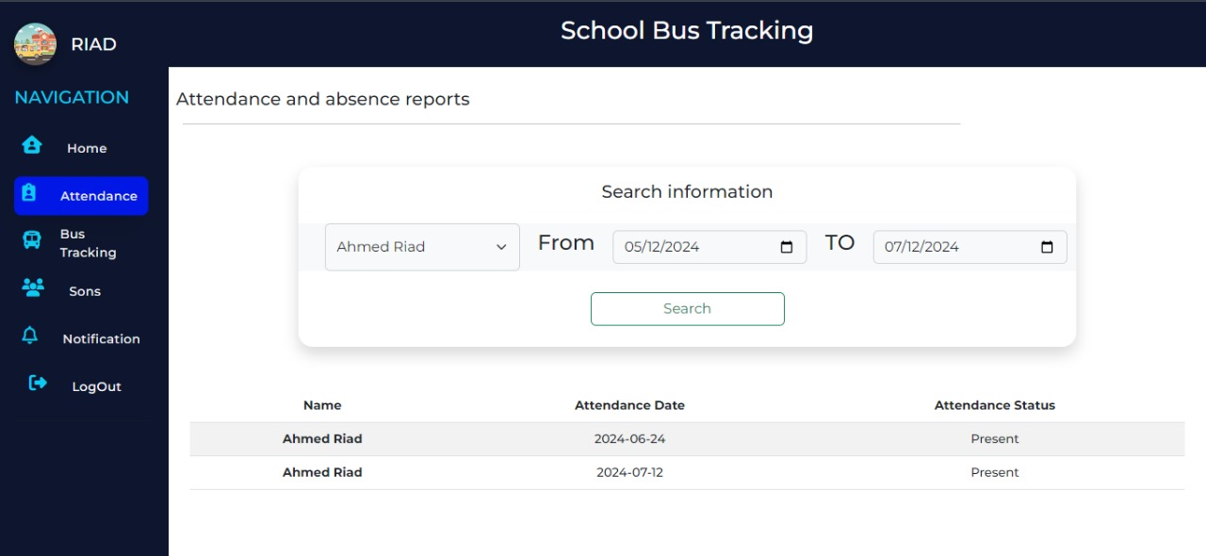As shown in Figure 49, the parent can show absence of their sons for more than day .

Figure 49: Sons Absence Page

As shown in Figure 50, the parent get notification of son status in bus or out of bus and bus status

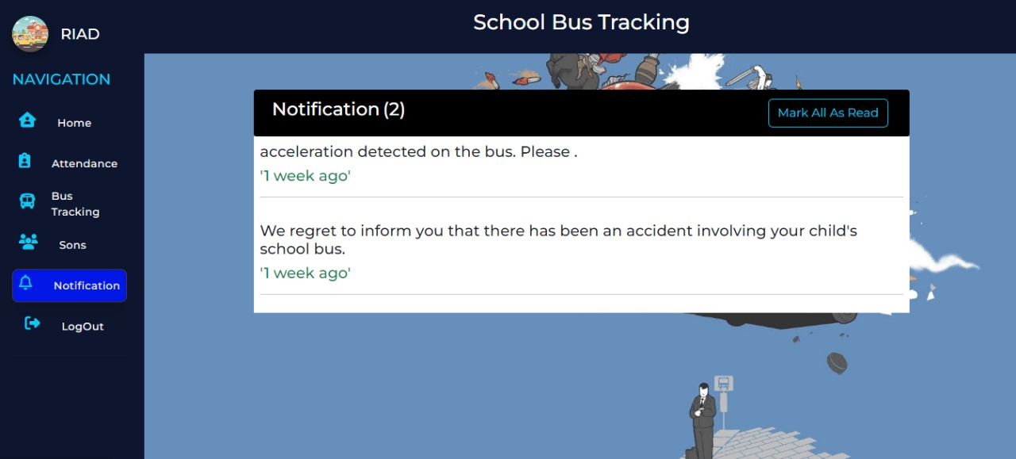

Figure 50: Notification Panel

As shown in Figure 51, the parent can track the bus.

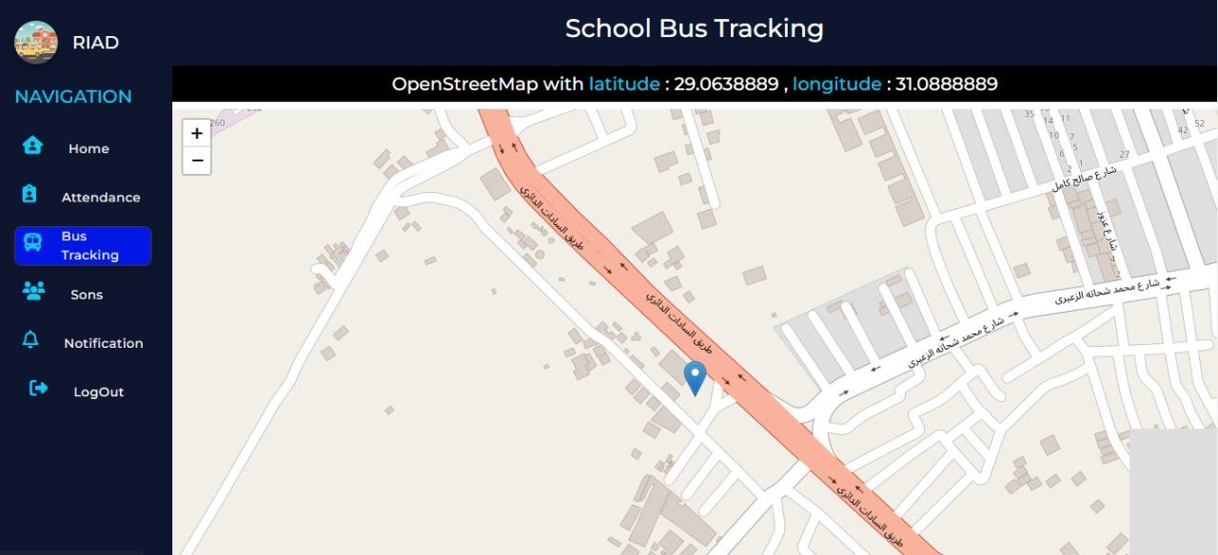

Figure 51: Tracking Page for Parent

**Chapter 7**

**Testing**

**Chapter 7**

**Testing**

**Chapter 7**

**Testing**

**Chapter 7**

**Testing**

**Chapter 7**

**Testing**

**Chapter 7**

**Testing**

**Chapter 7**

**Testing**

**Chapter 7**

**Testing**

**Chapter 7**

**Testing**

**Chapter 7**

**Testing**

**Chapter 7**

**Testing**

**Chapter 7**

**Testing**

**Chapter 7**

**Testing**

**Chapter 7**

**Testing**

**Chapter 7**

**Testing**

**Chapter 7**

**Testing**

**Chapter 7**

**Testing**

**Chapter 7**

**Testing**

**Chapter 7**

**Testing**

**Chapter 7**

**Testing**

**Chapter 7**

**Testing**

**Chapter 7**

**Testing**

**Chapter 7**

**Testing**

**Chapter 7**

**Testing**

**Chapter 7**

**Testing**

**Chapter 7**

**Testing**

**Chapter 7**

**Testing**

**Chapter 7**

**Testing**

**Chapter 7**

**Testing**

**Chapter 7**

**Testing**

**Chapter 7**

**Testing**

**Chapter 7**

**Testing**

**Chapter 7**

**Testing**

**Chapter 7**

**Testing**

**Chapter 7**

**Testing**

**Chapter 7**

**Testing**

**Chapter 7**

**Testing**

**Chapter 7**

**Testing**

**Chapter 7**

**Testing**

**Chapter 7**

**Testing**

**Chapter 7**

**Testing**

**Chapter 7**

**Testing**

**Chapter 7**

**Testing**

**Chapter 7**

**Testing**

**Chapter 7**

**Testing**

**Chapter 7**

**Testing**

**Chapter 7**

**Testing**

**Chapter 7**

**Testing**

**Chapter 7**

**Testing**

**Chapter 7**

**Testing**

**Chapter 7**

**Testing**

**Chapter 7**

**Testing**

**Chapter 7**

**Testing**

**Chapter 7**

**Testing**

**Chapter 7**

**Testing**

**Chapter 7**

**Testing**

**Chapter 7**

**Testing**

**Chapter 7**

**Testing**

**Chapter 7**

**Testing**

**Chapter 7**

**Testing**

**Chapter 7**

**Testing**

**Chapter 7**

**Testing**

**Chapter 7**

**Testing**

**Chapter 7**

**Testing**

# Testing

Validation and testing are crucial processes in software development, ensuring that the developed software meets the needs of the client or user.

The validation and testing process involves detailed testing of the project requirements and scenarios, ensuring that all critical functionalities of the application are thoroughly tested.

Verification is an important concept in testing, where the design, code, and program of the system are checked and evaluated, including reviews, walkthroughs, inspections, and desk-checking. On the other hand, validation focuses on checking whether the software meets the user needs and aligns with the specified requirements. In our system, this involves validating that the website functions correctly, the database stores and retrieves data accurately.

Testing plays a vital role in ensuring the proper functioning of website features like forms for adding new Admins, students, or parents. Through comprehensive testing, developers can validate the accuracy, security, integration, and user experience of these forms, providing a robust and reliable system that meets the needs and expectations of users.

Additionally, testing helps identify potential vulnerabilities or security loopholes in the form submission process. Developers can simulate various scenarios, such as submitting invalid or malicious data, to ensure that the website has proper input validation and sanitization mechanisms.

# Login (IT-Manager-Administrator-Parent)

In the Login (IT-Manager-Parent-Admin) testing, we focus on verifying the functionality of the login process for different roles within the system. This table outlines the test cases and their expected results to ensure a smooth and secure login experience.

**Table 4: Login (IT-Manager-Administrator-Parent) Testing**

|  |  |  |  |  |  |
| --- | --- | --- | --- | --- | --- |
| **Test Case ID** | **Test Scenario** | **Test Data** | **Expected Result** | **Actual Result** | **Situation** |
| TC-001 | Valid Email and  Password | Enter email "ahmedriad@gmaill.com" and password as "12345678". | User is successfully logged in. | User is successfully logged in. | Pass |
| TC-002 | Invalid email and valid Password | Enter invalid email "mohamed" and  valid password "12345678". | Error message is displayed, indicating invalid credentials. | Error message is displayed, indicating  invalid credentials. | Pass |
| TC-003 | valid Email and invalid Password | Enter valid email "ahmedriad@gmail.com" and invalid  password "1234567". | Error message is displayed, indicating invalid credentials. | Error message is displayed, indicating  invalid credentials. | Pass |
| TC-004 | Invalid Email and  Password | Enter invalid email "ahmed@gmail" and  invalid password "1234567". | Error message is displayed, indicating invalid credentials. | Error message is displayed, indicating  invalid credentials. | Pass |
| TC-005 | Empty Email and Password | Enter empty email " " and empty password  " ". | Error message is displayed, indicating  required fields are empty. | Error message is displayed, indicating  required fields are empty. | Pass |

# Add Admin

In the following table, the testing process for the "Add Admin" functionality is documented through different test cases. The goal is to verify the accuracy and reliability of the system when adding a new admin to the system.

**Table 5: Add Admin Testing**

|  |  |  |  |  |  |
| --- | --- | --- | --- | --- | --- |
| **Test Case**  **ID** | **Test Scenario** | **Test Data** | **Expected Result** | **Actual Result** | **Situation** |
| TC-001 | Valid full data | Name: 'Mohamed’  Email: 'mohamedessam@gmail.com'  Mobile: '01026626668'  Password: 'mohamed1' | Admin is successfully registered. | Admin is successfully registered. | Pass |
| TC-002 | Missing Required Information for one or more field | Name: 'Mohamed’  Email: 'mohamedessam@gmail.com'  Mobile: ''  Password: 'mohamed1' | Error message is displayed, indicating invalid credentials. | Error message is displayed, indicating invalid credentials. | Pass |
| TC-003 | One or more field with invalid data | Name: 'Mohamed’  Email: 'mohamedessam@gmail.com'  Mobile: '015588'  Password: 'moha' | Error message is displayed, indicating invalid credentials. | Error message is displayed, indicating invalid credentials. | Pass |

# Add Student

In Add Student testing, we verify the functionality of adding Student data to the system. Test cases are conducted to cover different scenarios, such as valid full data entry, missing required information for one or more fields, and invalid data entry. The expected results are compared with the actual results to ensure the accuracy of student registration.

**Table 6: Add Student Testing**

|  |  |  |  |  |  |
| --- | --- | --- | --- | --- | --- |
| **Test Case ID** | **Test Scenario** | **Test Data** | **Expected Result** | **Actual Result** | **Situation** |
| TC-001 | Valid full data | Name: 'Hanaa'  Gender: 'female' email: ‘hanaa@gmail.com’ Mobile: '01022668888'  National ID: “30509072200311”  Birtdate: 01/05/2001  Grade: ‘Secondary’  Classroom: ‘Second’  Section: ‘A’  Parent: ‘Mohamed’ | Student is successfully registered. | Student is successfully registered. | Pass |
| TC-002 | Missing Required Information for one or more field | Name: 'Hanaa'  Gender: 'female' email: ‘  Mobile: ''  National ID: “”  Birtdate:  Grade: ‘Secondary’  Classroom: ‘Second’  Section: ‘A’  Parent: ‘Mohamed’ | Error message is displayed, indicating invalid credentials. | Error message is displayed, indicating invalid credentials. | Pass |
| TC-003 | One or more field with invalid data | Name: 'Hanaa'  Gender: 'female' email: ‘mohamed@gmail’  Mobile: '01011223'  National ID: “3055151551”  Birtdate: 01/05/2001  Grade: ‘Secondary’  Classroom: ‘Second’  Section: ‘A’  Parent: ‘Mohamed’ | Error message is displayed, indicating invalid credentials. | Error message is displayed, indicating invalid credentials. | Pass |

# Parent Registration

In Parent Registration testing, we focus on adding parent data to the system. Similar to the previous table, test cases are designed to cover various scenarios, including valid data entry, missing required information, and invalid data entry. The expected and actual results are compared to ensure parent registration.

**Table 7: Parent Regiseration Testing**

|  |  |  |  |  |  |
| --- | --- | --- | --- | --- | --- |
| **Test Case**  **ID** | **Test Scenario** | **Test Data** | **Expected Result** | **Actual Result** | **Situation** |
| TC-001 | Valid full data | Name: 'Mohamed’  Email: 'mohamedessam@gmail.com'  Mobile: '01026626668'  Password: 'mohamed1' | Parent is successfully registered. | Parent is successfully registered. | Pass |
| TC-002 | Missing Required Information for one or more field | Name: 'Mohamed’  Email: 'mohamedessam@gmail.com'  Mobile: '01026626668'  Password: '' | Error message is displayed, indicating invalid credentials. | Error message is displayed, indicating invalid credentials. | Pass |
| TC-003 | One or more field with invalid data | Name: 'Mohamed’  Email: 'mohamedessam@gmail.com'  Mobile: '01026626668'  Password: 'moha' | Error message is displayed, indicating invalid credentials. | Error message is displayed, indicating invalid credentials. | Pass |

# Delete (Admin-Parent-Student)

Delete (Admin-Parent-Student) testing focuses on testing the delete functionality for different user types. Test cases are designed to verify the successful deletion of selected users from the system.

**Table 8: Delete (Admin-Parnet-Student) Testing**

|  |  |  |  |  |  |
| --- | --- | --- | --- | --- | --- |
| **Test Case**  **ID** | **Test Scenario** | **Test Data** | **Expected Result** | **Actual Result** | **Situation** |
| TC-001 | Click Delete Button | Selected Row of Data in The Table | Selected User is successfully Deleted. | Selected User is successfully  Deleted from Table. | Pass |

# Edit (Admin-Parent-Student)

In Edit (Admin-Parent-Student) testing, we test the edit functionality for different user types. Test cases involve selecting a user, making edits, and saving the changes. The expected and actual results are compared to ensure the successful editing of user data.

**Table 9: Edit (Admin-Parent-Student) Testing**

|  |  |  |  |  |  |
| --- | --- | --- | --- | --- | --- |
| **Test Case ID** | **Test Scenario** | **Test Data** | **Expected Result** | **Actual Result** | **Situation** |
| TC-001 | Click Edit Button then Save Edit | Selected Row of Data in The Table | Selected User is successfully Edited. | Selected User Data is successfully Edited. | Pass |

# Search Student Attendance

Test cases for searching student attendance by name aim to validate the accuracy and reliability of the search feature within the school bus tracking system. Each test case is designed to ensure that the system correctly retrieves attendance records based on the input name provided by the user. The tests cover various scenarios such as searching for names that exist in the database, names that do not exist, partial matches, and edge cases like special characters or unexpected input formats. Additionally, the tests verify the system's ability to handle large datasets efficiently without compromising search performance.

**Table 10: Search Student Attendance Testing**

|  |  |  |  |  |  |
| --- | --- | --- | --- | --- | --- |
| **Test Case ID** | **Test Scenario** | **Test Data** | **Expected Result** | **Actual Result** | **Situation** |
| TC-001 | Valid full Data | Name: ‘Mohamed’  Startdate: ‘01/05/2024’  Enddate: ‘7/11/2024’ | Show if student attended or absent between the given dates | Show if student attended or absent between the given dates | Pass |

# 

**Chapter 8**

**Conclusion & Future Work**

**Chapter 8**

**Conclusion & Future Work**

**Chapter 8**

**Conclusion & Future Work**

**Chapter 8**

**Conclusion & Future Work**

**Chapter 8**

**Conclusion & Future Work**

**Chapter 8**

**Conclusion & Future Work**

**Chapter 8**

**Conclusion & Future Work**

**Chapter 8**

**Conclusion & Future Work**

**Chapter 8**

**Conclusion & Future Work**

**Chapter 8**

**Conclusion & Future Work**

**Chapter 8**

**Conclusion & Future Work**

**Chapter 8**

**Conclusion & Future Work**

**Chapter 8**

**Conclusion & Future Work**

**Chapter 8**

**Conclusion & Future Work**

**Chapter 8**

**Conclusion & Future Work**

**Chapter 8**

**Conclusion & Future Work**

**Chapter 8**

**Conclusion & Future Work**

**Chapter 8**

**Conclusion & Future Work**

**Chapter 8**

**Conclusion & Future Work**

**Chapter 8**

**Conclusion & Future Work**

**Chapter 8**

**Conclusion & Future Work**

**Chapter 8**

**Conclusion & Future Work**

**Chapter 8**

**Conclusion & Future Work**

**Chapter 8**

**Conclusion & Future Work**

**Chapter 8**

**Conclusion & Future Work**

**Chapter 8**

**Conclusion & Future Work**

**Chapter 8**

**Conclusion & Future Work**

**Chapter 8**

**Conclusion & Future Work**

**Chapter 8**

**Conclusion & Future Work**

**Chapter 8**

**Conclusion & Future Work**

**Chapter 8**

**Conclusion & Future Work**

**Chapter 8**

**Conclusion & Future Work**

**Chapter 8**

**Conclusion & Future Work**

**Chapter 8**

**Conclusion & Future Work**

**Chapter 8**

**Conclusion & Future Work**

**Chapter 8**

**Conclusion & Future Work**

**Chapter 8**

**Conclusion & Future Work**

**Chapter 8**

**Conclusion & Future Work**

**Chapter 8**

**Conclusion & Future Work**

**Chapter 8**

**Conclusion & Future Work**

**Chapter 8**

**Conclusion & Future Work**

**Chapter 8**

**Conclusion & Future Work**

**Chapter 8**

**Conclusion & Future Work**

**Chapter 8**

**Conclusion & Future Work**

**Chapter 8**

**Conclusion & Future Work**

**Chapter 8**

**Conclusion & Future Work**

**Chapter 8**

**Conclusion & Future Work**

**Chapter 8**

**Conclusion & Future Work**

**Chapter 8**

**Conclusion & Future Work**

**Chapter 8**

**Conclusion & Future Work**

**Chapter 8**

**Conclusion & Future Work**

**Chapter 8**

**Conclusion & Future Work**

**Chapter 8**

**Conclusion & Future Work**

**Chapter 8**

**Conclusion & Future Work**

**Chapter 8**

**Conclusion & Future Work**

**Chapter 8**

**Conclusion & Future Work**

**Chapter 8**

**Conclusion & Future Work**

**Chapter 8**

**Conclusion & Future Work**

**Chapter 8**

**Conclusion & Future Work**

**Chapter 8**

**Conclusion & Future Work**

**Chapter 8**

**Conclusion & Future Work**

**Chapter 8**

**Conclusion & Future Work**

**Chapter 8**

**Conclusion & Future Work**

**Chapter 8**

**Conclusion & Future Work**

# Conclusion

In conclusion, our bus school tracking system project has successfully demonstrated the integration of advanced embedded systems, real-time operating systems, and web technologies to enhance the safety and monitoring of school transportation. Utilizing the ATmega128 microcontroller, along with the MFRC522 RFID sensor for attendance, the NEO 6M GPS module for location tracking, and the ADXL345 accelerometer for accident detection, we have developed a robust hardware platform. FreeRTOS was employed to manage multitasking and synchronization, ensuring reliable and efficient operation of the system.

The system's communication is facilitated by the MQTT protocol, enabling real-time data transmission from the bus to the web server. This data is then accessible through a user-friendly web application designed for IT managers, administrators, and parents. Each stakeholder has specific functionalities tailored to their needs, such as managing user roles, monitoring attendance, and ensuring student safety.

Through rigorous testing and real-world validation, we have ensured that our system meets the necessary requirements for accuracy, reliability, and user satisfaction. Additionally, the system is designed to be scalable, allowing for future expansions and enhancements. Recommendations for further development include enhancing security measures, expanding functionality with additional sensors, improving the user experience with mobile applications, and integrating data analytics for predictive insights.

# Future Work

Moving forward, there are several avenues for future work and enhancements to our bus school tracking system.

* + 1. Implementing camera-based attendance verification to complement or replace RFID technology for higher accuracy.
    2. Creating mobile apps for parents and administrators to improve accessibility and user experience.
    3. Adding more sensors, such as CO2 detectors for air quality monitoring, to enhance overall safety.
    4. Implementing algorithms for optimizing bus routes to save time and fuel.

By pursuing these future enhancements, the bus school tracking system can evolve to offer even greater functionality, reliability, and user satisfaction, ultimately contributing to the safety and efficiency of school transportation.

**Chapter 9**

**References**

**Chapter 9**

**References**

Figure : Kernel Structure

**Chapter 9**

**References**

**Chapter 9**

**References**

Figure : Kernel Structure

**Chapter 9**

**References**

**Chapter 9**

**References**

Figure : Kernel Structure

**Chapter 9**

**References**

**Chapter 9**

**References**

Figure : Kernel Structure

**Chapter 9**

**References**

**Chapter 9**

**References**

Figure : Kernel Structure

**Chapter 9**

**References**

**Chapter 9**

**References**

Figure : Kernel Structure

**Chapter 9**

**References**

**Chapter 9**

**References**

Figure : Kernel Structure

**Chapter 9**

**References**

**Chapter 9**

**References**

Figure : Kernel Structure

**Chapter 9**

**References**

**Chapter 9**

**References**

Figure : Kernel Structure

**Chapter 9**

**References**

**Chapter 9**

**References**

Figure : Kernel Structure

**Chapter 9**

**References**

**Chapter 9**

**References**

Figure : Kernel Structure

**Chapter 9**

**References**

**Chapter 9**

**References**

Figure : Kernel Structure

**Chapter 9**

**References**

**Chapter 9**

**References**

Figure : Kernel Structure

**Chapter 9**

**References**

**Chapter 9**

**References**

Figure : Kernel Structure

**Chapter 9**

**References**

**Chapter 9**

**References**

Figure : Kernel Structure

**Chapter 9**

**References**

**Chapter 9**

**References**

Figure : Kernel Structure

**Chapter 9**

**References**

**Chapter 9**

**References**

Figure : Kernel Structure

**Chapter 9**

**References**

**Chapter 9**

**References**

Figure : Kernel Structure

**Chapter 9**

**References**

**Chapter 9**

**References**

Figure : Kernel Structure

**Chapter 9**

**References**

**Chapter 9**

**References**

Figure : Kernel Structure

**Chapter 9**

**References**

**Chapter 9**

**References**

Figure : Kernel Structure

**Chapter 9**

**References**

**Chapter 9**

**References**

Figure : Kernel Structure

**Chapter 9**

**References**

**Chapter 9**

**References**

Figure : Kernel Structure

**Chapter 9**

**References**

**Chapter 9**

**References**

Figure : Kernel Structure

**Chapter 9**

**References**

**Chapter 9**

**References**

Figure : Kernel Structure

**Chapter 9**

**References**

**Chapter 9**

**References**

Figure : Kernel Structure

**Chapter 9**

**References**

**Chapter 9**

**References**

Figure : Kernel Structure

**Chapter 9**

**References**

**Chapter 9**

**References**

Figure : Kernel Structure

**Chapter 9**

**References**

**Chapter 9**

**References**

Figure : Kernel Structure

**Chapter 9**

**References**

**Chapter 9**

**References**

Figure : Kernel Structure

**Chapter 9**

**References**

**Chapter 9**

**References**

Figure : Kernel Structure

**Chapter 9**

**References**

**Chapter 9**

**References**

# 9.1 References

1. **UNICEF, "Egyptian school enrollment during the 2019-2020 academic year," 2019-2020.**
2. **(Available Online)** [8 Real-world Challenges Faced Day-to-day in School Bus GPS Tracking Systems » Asti Infotech Blogs](https://blog.astiinfotech.com/8-real-world-challenges-faced-day-to-day-in-school-bus-gps-tracking-systems/)
3. **(Available Online)** [**https://www.hivemq.com/blog/mqtt-vs-http-protocols-in-iot-**](https://www.hivemq.com/blog/mqtt-vs-http-protocols-in-iot-iiot/)[**iiot/**](https://www.hivemq.com/blog/mqtt-vs-http-protocols-in-iot-iiot/)
4. **(Available Online)**  [microchip.com/en-us/product/atmega128](https://www.microchip.com/en-us/product/atmega128)
5. **(Available Online)** [ESP-01 Datasheet, PDF - Alldatasheet](https://www.alldatasheet.com/view.jsp?Searchword=Esp-01%20datasheet&gad_source=1&gclid=EAIaIQobChMIlZ-P0KafhwMVSEBBAh09BgHlEAAYASAAEgJ2wvD_BwE)
6. **(Available Online)** [NEO-6 Datasheet by SparkFun Electronics | Digi-Key Electronics (digikey.com)](https://www.digikey.com/htmldatasheets/production/2757457/0/0/1/neo-6.html)
7. **(Available Online)**  [ADXL345 Datasheet and Product Info | Analog Devices](https://www.analog.com/en/products/adxl345.html#:~:text=The%20ADXL345%20is%20a%20small,suited%20for%20mobile%20device%20applications.)
8. **(Available Online)** <https://www.alldatasheet.com/view.jsp?Searchword=Mfrc522%20datasheet&gad_source=1&gclid=CjwKCAjwqMO0BhA8EiwAFTLgIMTO3OHsHeGhmFbX9wLEuxOkwtTvaqcrSxf2kw2qvjRg-VVQ9i5gXxoCKnUQAvD_BwE>
9. **(Available Online)** [**https://www.vishay.com/doc/?37306=**](https://www.vishay.com/doc/?37306=)
10. **(Available Online)** [**https://laravel.com/docs/11.x/scheduling**](https://laravel.com/docs/11.x/scheduling)
11. **(Available Online)** [**https://laravel.com/docs/11.x/queues**](https://laravel.com/docs/11.x/queues)
12. **(Available Online)** [**https://laravel.com/docs/11.x/notifications**](https://laravel.com/docs/11.x/notifications)
13. **(Available Online)** [**https://laravel.com/docs/11.x/eloquent**](https://laravel.com/docs/11.x/eloquent)
14. **(Available Online)** [**https://react.dev/**](https://react.dev/)
15. **(Available Online)** [**https://leafletjs.com/reference.html#map-example**](https://leafletjs.com/reference.html#map-example)
16. **(Available Online)** [**https://documenter.getpostman.com/view/28340844/2s9Yyy9KAZ**](https://documenter.getpostman.com/view/28340844/2s9Yyy9KAZ)